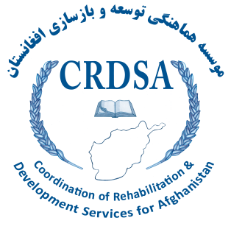


Final Report

Of

Socio-economic Survey and Market Assessment

In “IDP/Returnee" populated areas of Herat Province

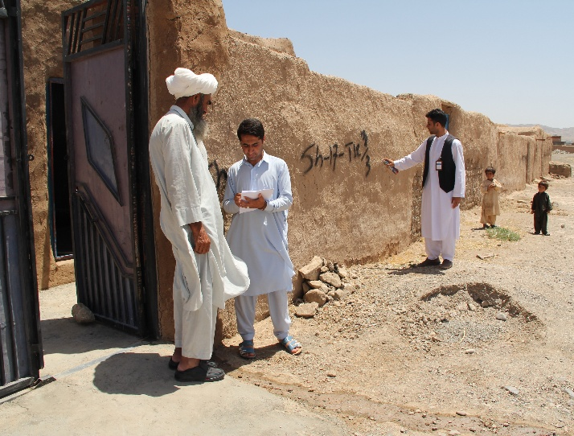

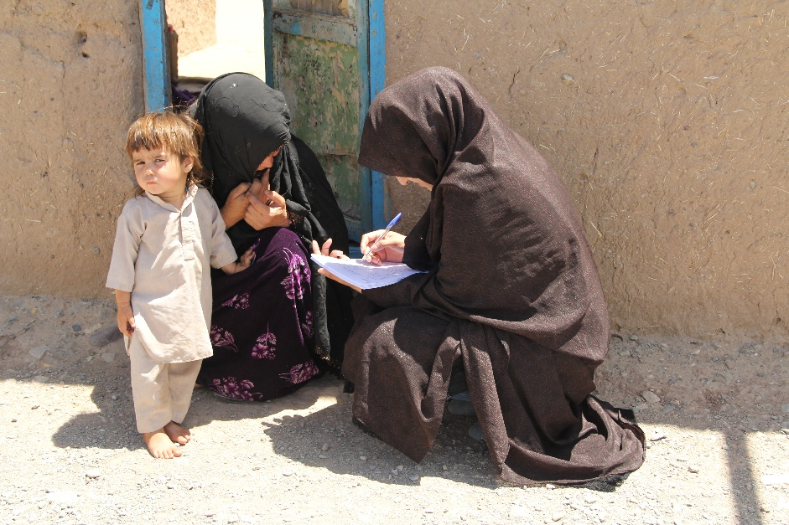

Implemented by: CRDSA
Funded by: UNHCR

2017
Table of Contents
Acknowledgment 1
Executive summary 2
List of abbreviations/ Acronyms 3
Definition of Terms and expressions used in this survey and report 4
Methodology 5
Herat IDPs Settlement Profile 6
1. Shoghofan 6
2. Jebrael 6
3. Maslakh 6
4. Now Abad 7
5. Kahdistan 7
Socio-economic Survey Findings 8
1- Category of Interviewees 8
2- Demography breakdown 8
3- Where do the returnees return to Afghanistan 8
4- Role of interviewees in HHs 8
5- Total population of families who surveyed 9
6- Persons with Disability 9
7- Holding civil documentation ( ID cards) 9
8- Presence of CDCs into communities and level of IDPs/returnees participation in CDC structure 10
9- Reasons behind internally displacement 11
10- Involvement of IDPs/returnees in Agriculture activities in targeted areas 11
11- Accessibility to shelter 12
12- IDPs/ returnees houses/shelters facilities and satisfactions and accessibility condition 12
13- Condition of Physical accessibility to houses by road 13
14- Accessibility to electricity and experiencing problem to access to electricity 13
15- Monthly Electricity Expenditure 14
16- Main sources of electricity in target areas 14
17- Accessibility to water for drink and personal purposes 15
18- Families’ problem to access to water inside home and target communities 15
19- Adequacy of water available in home and communities 16
20- Access to Health services 16
Community members/ families satisfaction from health services provided by HFs 17
21- Access to education 17
22- Accessibility to University by IDPs, returnees in target locations 18
23- Availability of market to fulfill daily basic needs of families 18
24- Accessibility to daily wage labor market inside and nearby target communities 18
25- Source of money to support families in case of no daily wage labor market 19
26- Perform work in last month by breadwinner of the families 19
27- Self-classification of families from earning the income aspect 19
28- Approach to earn income 20
29- Types of work which families do 21
30- Community interest on the most profitable jobs in target communities 22
31- Families average monthly income 23
32- Reasons behind head of families are not employed 23
33- Existed skills/professions amongst targeted families 24
34- Helpful options to improve livelihood opportunities for target families 24
35- Proposed skills 25
36- Community main priorities 26
Challenges: 26
Recommendations 27
Conclusion 28

Acknowledgment
Conducting such big survey covering 12000 families in very short time was a very sensitive and complicated task and CRDSA was come up successfully to perform it in determined time. CRDSA management team is grateful from UNHCR for their trust on CRDSA and supporting CRDSA staffs to do this job perfectly, otherwise the implementation of this survey was very hard. CRDSA would like to express their sincere gratitude to the Herat governorate office, DoRR, DoLSAMD and Police Department for their support and collaboration for implementation of this survey. In particular the DoRR Directorate contributed in the survey physically through supervising and overseeing the survey process. UNHCR staffs in particular Mr. Wahid Homan, Eng. Wakil Ahmad Habibi, Mrs. Fariba Noorzai and Mr. Hayatullah Jawid had very active and instructive roles at the beginning to end of survey through provision of technical support for CRDSA staffs, surveyors training and field visit to find any gap occurs within the survey. CRDSA is cordially thankful from their active support and collaboration. The role of police in terms of provision of reliable security umbrella for surveyors was appreciable. The police staffs tried hard to provide safe and secure environment for surveyors and supervisors. CRDSA is also thankful from CDCs in target areas for their good coordination and communication with community members; they had active role in convincing the community members on objective of survey and the issue that the survey must be done accurately. The CDCs accompanied CRDSA surveyors door by door. Furthermore, we would like to express our deep appreciations to the IDPs, returnees and vulnerable host community members who opened their homes to us and shared their stories and who despite dire living conditions continue to display hope and optimism. 15 supervisors with 150 surveyors made the survey succeed in accordance with objectives and indicators, so CRDSA is cordially thanking them and wishing them all the best. CRDSA staffs were assigned to enter all data gathered from the field, they did their job very good and the data kept confidential and noting was shared with others. Without the support of those listed above and many more that are not named here, this report and initiative would not have been possible.
Eventually this survey was a good opportunity for CRDSA to prove its capability to perform such big survey in very short time through rapid training of surveyors, resource mobilization, program supervision, data collection, data entry, data analysis and creation of Report of Survey. Thanks to all who made this initiative successful.
Analyzing the data and producing a standard report requires high knowledge and report writing skills. I am grateful from Dr. Gul Ahamd “Rashad” and Mr. Aminullah “Bavar” for preparing and designing this report and wishing them all the best.

Sincerely
Dr. Aziz Ahmad Jami
Managing Director of CRDSA

Executive summary
Herat province and in particular Herat city is located in western Afghanistan. This province has 15 provincial district plus Herat city. Herat city has 13 urban districts. Herat province has land border with Iran and Turkmenistan which has given to Herat as hub of the business, transit, culture, tourism and welfare. These characteristics have motivated a lot of business men, small and medium enterprisers, to select Herat as their resident place. This normal trend of population movement was interrupted by war and insecurity in last 40 years. Since 1991, thousands of Heratian who had to leave the country due to war, repatriated to their villages. In addition, many afghan returnees stayed in Herat despite go to their place of origins as the resources and opportunities were very much more than the resources in their place of origins. Such massive repatriation imposed heavy pressure on available resources in Herat. This phenomenon was getting intensified when the country experience domestic war in last 25 years so far. At the end of 2015 Herat was amongst the highest IDP hosting provinces in Afghanistan accounting for approximately 10% or 120,000 of the IDP population, comprised of a significant protracted IDP caseload, some of whom have lived in Herat for as long as two decades. Despite living in Herat for more than 2 decades, but many of IDPs and returnees live in very poor living conditions. They are mainly deprived form their rights. Despite receiving aids for years, they still in need of livelihood, food security, shelter, NFI, education, health and holding civil documentation. However the Government of Islamic Republic of Afghanistan has decided to relocate all IDPs into to township in Maslakh and Karizak, but there is no significant performance seen in this area. There are many IDPs families live in inappropriate homes which have been made from mud bricks with poor condition in Maslakh camp. A number of IDPs and returnees live in rental homes which imposes them extra pressure to prepare the monthly rental fee.
In order to have a clear and reliable information on socio-economic condition of IDPs, Returnees in Herat, UNHCR supported technically and financially CRDSA to conduct a comprehensive survey on socio-e economic condition of returnees, and IDPs in 5 most crowed/ populated IDP- returnees settlements ( Shagofan, Jebraiel, Maslakh western Herat city and Now Abad and Kahdistan eastern Herat city. The survey was extensively coordinated with line departments, target CDCs and UNHCR at Herat and Kabul level. CRDSA in collaboration with UNHCR finalized a comprehensive questionnaire which was introduced and orientated to supervisors and surveyors through one day training.
The survey findings are summarized as follow:
- The survey revealed that over 77% of total target families live under the poverty line with having serious livelihood and protection gaps.
- 0ver of 38% of total target families have no access to safe drinking water.
- Over 60% of heads of families (12000 families) have no skill to utilize them for their livelihood and they are fully dependent on non- skilled labor with minimum wages

List of abbreviations/ Acronyms
AIHRC Afghanistan Independent Human Rights Commission
BPHS Basic Package of Health Services
CRDSA Coordination of Rehabilitation and Development Services for Afghanistan
DoRR Directorate of Refugees Repatriation
DoLSAMD Directorate of labor Social Affairs, Martyrs and Disabled
EPHS Essential Package of Hospital Services
HFs Health Facilities
IDP Internally Displaced persons
MoRR Ministry of Refugees and Repatriation
MRRD Ministry of Rural Rehabilitation and Development
MoPH Ministry of Public Health
NSP National Solidarity Program
SDGs Sustainable Development Goals
CC Citizen Charter
PWDs Persons with Disabilities
SME Small and Medium Enterprise
UNHCR United Nation High Commissioner for Refugees
UN United Nations

Definition of Terms and expressions used in this survey and report
Socio- economic Survey:
Socio-economic survey is a systematic process of gathering reliable, scientific and accurate information of target population on their social and economic conditions through direct, face to face interview based on well-structured questionnaire.
Family: Consisting of a husband, wife (or wives), and unmarried children and direct dependents such as elderly parents/grandparents; or a single head-of-household (male or female) and his/her unmarried children.

Head of family: The head of family can be a male or female, in which one adult is responsible for the decision-making in the whole family. A female-headed family is a family where a woman alone is responsible for the family.

Household: The household (HH) is “the basic residential unit’ on a single plot of land with the members sharing the same entrance door and cooking together.

Internally Displacement: The involuntary or forced movement, evacuation or relocation of persons or groups of persons within internationally recognized state borders.

Internally Displaced Person (IDP): An IDP is a person who has been forced or obliged to flee, or to leave their homes or place of habitual residence, in particular as a result of or in order to avoid the effects of armed conflict, situations of generalized violence or violations of human rights, and who have not crossed an internationally recognized State border. (Also refer the National IDP Policy 2013)

Local integration: A solution whereby an IDP or a returnee is able to participate fully in the economic, social and cultural life of the area they are living in; enjoys the same rights and standards of living and is integrated into the local community.

Returnees: A returnee is a person who has gone through the process of return- who was refugee in a foreign country and has returned to Afghanistan.

Methodology
In order to have a clear and reliable information on socio-economic condition of IDPs, Returnees in Herat, UNHCR supported technically and financially CRDSA to conduct a comprehensive survey on socio-e economic condition of returnees, and IDPs. According to the statistics of the DoRR Herat and other active humanitarian agenicies/institutions that are supporting IDP/returnees in Herat, approximately around 120,000 IDP/returnee HHs are living in 5 most crowed/ populated IDP- returnees settlements ( Shagofan, Jebrael, Maslakh western Herat city, Now Abad and Kahdistan eastern Herat city).

Sampling strategy:
In order to insure that every unit in the population has the same chance of being selected in the sample; we have used from Probabilistic sampling, CLUSTER SAMPLE as a multi-stage sampling technique (districts, villages, Townships) and based on the pragmatic statistical sampling strategies; after defining the population of concern, the following steps were taken place:
- Specifying a sampling method for selecting households out of the sampling frame;
- Determine the sample size;
- Implementing the sampling plan;
- Sampling and data collecting;
Consequently ;
- The population of region were sampled within 10 IDP/returnee settlement areas.
- 5 out of 10 areas were selected based on the most crowded/populated areas of IDPs and returnees in.
- Within each selected area, we took the list of villages in alphabetic order and applied the systematic sampling to select parallel households with same vulnerability changing aspects.
- Within each location/area we selected village that were taken from the list of the inhabitants in alphabetic order and applied the systematic sampling.
Number of households in the selected settlements at the time of the survey were as below:
- Shoghofan: 3,000 sample (HHs) out of 5,700 (HHs)
- Jebrael: 3,000 sample (HHs); out 20,000 (HHs)
- Maslakh: 4,000 sample (HHs); out of 7,000 (HHs)
- Now Abad: 1,000 sample (HHs); out of 3,000 (HHs)
- Kahdestan: 1,000 sample (HHs); out of 3,000 (HHs)
- Total: 12,000 sample (HHs); out of 38,700 (HHs)

The survey was extensively coordinated with line departments, target CDCs and UNHCR at Herat and Kabul level. CRDSA in collaboration with UNHCR finalized a comprehensive questionnaire which was introduced and orientated to supervisors and surveyors through one day training.
The socio-economic survey was designed into following phases:
- Coordination with UNHCR, DoRR, DoLSAMD, Police department and target community shuras
- Finalization of questionnaire in collaboration with UNHCR
- Selection of supervisors and surveyors
- Conduct training for supervisors , introduction of questionnaire to supervisors, and determination of codes for HH survey
- Formation of teams including supervisor with 15 surveyors
- Conduct training for surveyors, introduction of questionnaire, filling the questionnaire through role play
- Assigning team to specific locations and engaging community Shuras to support/accompany team member to reach to house to house survey
- Conducting survey of 12,000 families for a period of 5 days
- Direct supervision of teams, surveyors and review their filled questionnaires to make sure that the process is done in accordance with CRDSA, UNHCR demands
- Review of filled questionnaires with supervisors at the end of the day and rejecting incomplete questionnaires
- Development of data bases for data entry by CRDSA IT department in collaboration with IT department of UNHCR
- Conduct orientation session for data entry staff and introduction of data bases and modality of data entry in accurate methods
- Entering the data gathered from the field by CRDSA staffs
- Data processing and making the report
- Conducing market assessment through visiting companies, enterprises, private sectors to realize their needs, problems and possible intervention
- Making the report of market assessment Sharing the reports ( draft and final versions) to UNHCR
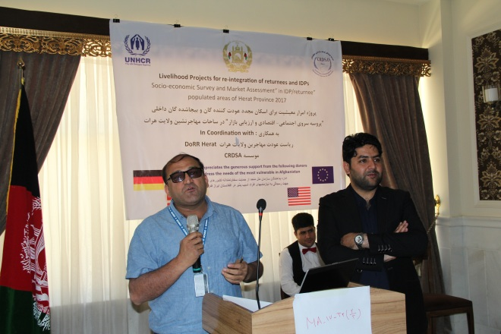
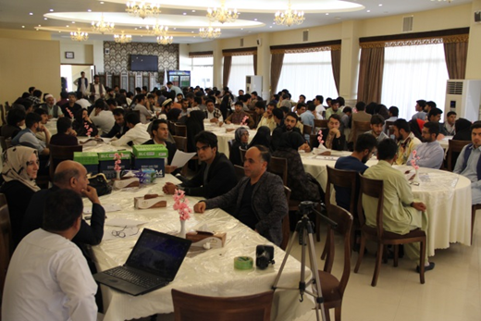

Figure 2: UNHCR Staff explains the objectives of survey to survey teams
Figure 1: Supervisors discuss with Survey team members

Herat IDPs Settlement Profile
CRDSA has completed the socio- economic survey of 12,000 families in 5 target locations:

Shoghofan
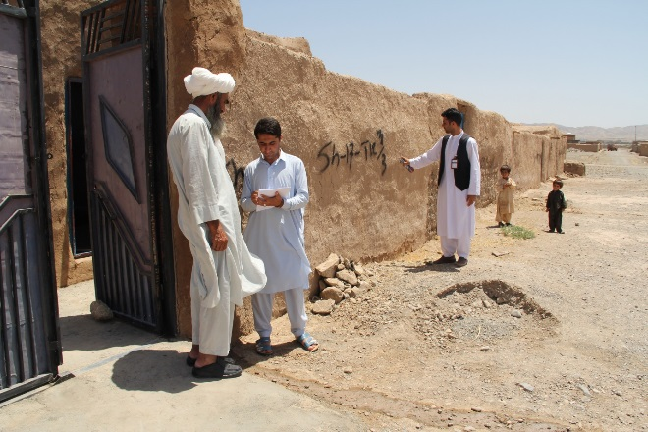
This returnees/IDP settlement is located 10 kilometers away from the Herat city Injil District, western direction of Herat. The area is located round the Herat- Islam Qala high way which contains 9 areas with different names, but total called Shagofan. 100% of the residents of this area are IDPs and returnees. They are from different provinces of Afghanistan (Bamyan, Ghor, Oruzgan, Faryab, Kunduz and provincial district of Herat. the residents are mainly Hazaras and Pashtuns. However the residents of this area have been benefited from humanitarian aid such shelter, livelihood support, WASHES, and protection support, but they are still in need.

Jebrael
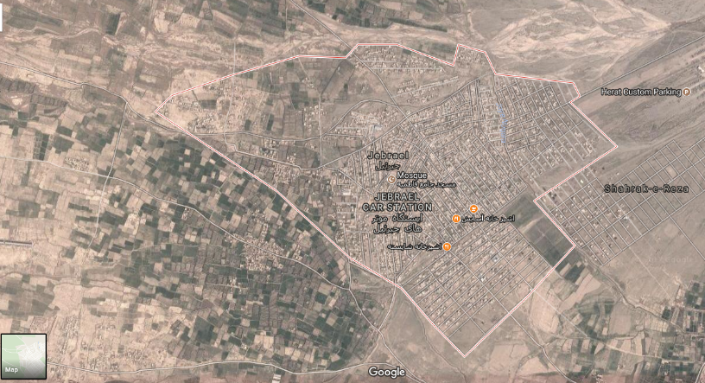
This township is one of the high crowded IDPs/returnees settlements in Herat which is hosting thousands of families in 2 past decades so far. The majority of inhabitants of Jebieil are Hazara. Other tribal groups also live in Jebrael. They are from different provinces of the country, despite of benefiting from humanitarian aids; they are still in needs to be fully integrated. CRDSA surveyed 3,000 returnees/IDPs families in Jebrael area during socio-economic survey.

Maslakh
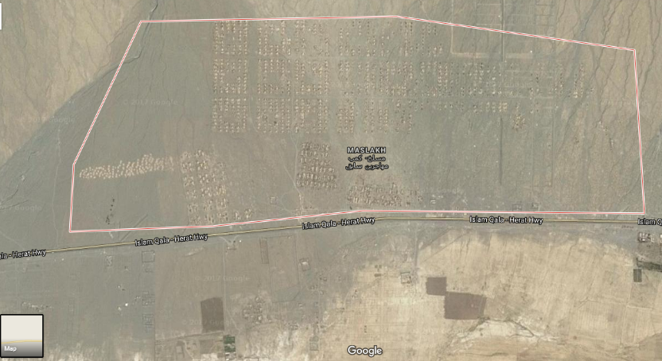
Thousands of Afghan families, who had to abandon their place of origins due to armed conflicts and natural disasters, were located in Maslakh camp. However in 2003 the GoIRA decided to relocate the inhabitants of Maslakh camp to their place of origins and thousands of IDPs relocated, but due to security deterioration, the relocation process was stopped and even many families returned back to this area. They live in houses which have been built form mud bricks. However the residents of Maslakh are from different provinces, but overwhelming majority of them are Pashtuns. Despite living for several years in Herat, but there are lots of protection gaps in the areas and the residents by no means have been integrated into Herat community. Many of families at the risk of food insecurity and their food stock is not covering more than one month. Despite of existing school in the area, but overwhelming majority of girls are not going to school. The residents of Maslakh still have no electricity, shortage of safe drinking water, poor livelihood condition. CRDSA surveyed 4000 IDP families in Maslakh area during the survey, 100% of residents were interviewed.

Now Abad
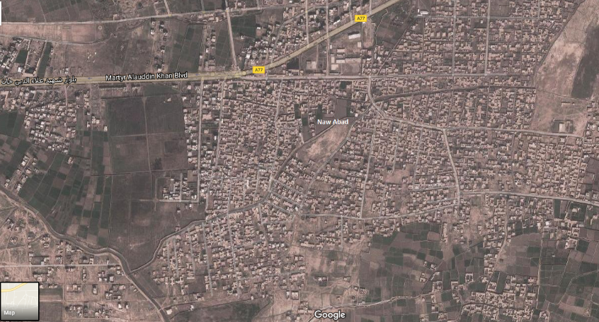
Now Abad is a high crowded area of host communities and IDPs in Herat, overwhelming majority of IDPs in Now Abad are from Herat districts e.g. Karukh, Pashtun Zarghoon, Gulran, Obe and etc. while the IDPs from other provinces in particular Badghis live in the area. However there is public school, health clinic, urban services such electricity, in the area, but overcrowdings of IDPs poses extra pressure on available resources and coping mechanism. This issue creates lots of protection gaps in livelihood, and access to basic services such education (particularly girl education) health and psycho social services. CRDSA surveyed 1000 families who are IDPs in this area.

Kahdistan
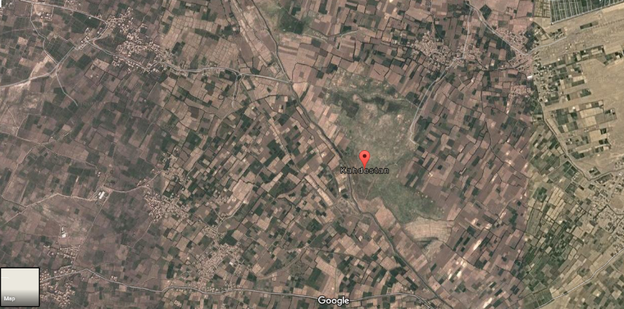
Kahdistan is a village of Injil district which has been located in 5 kilometers far away from Herat city. However this village is an area of host community members, but in recent years, hundreds of IDP and returnees families were located in this area. The returnees are mainly from Faryab and Kunduz provinces which have been returned from Pakistan since 2014 so far. However there are school, health facility inside the village, but the level of accessibility of IDPs and returnees families to these services are poor. There are many protection gaps such livelihood, access to education, health and integration measures in IDPs/returnees settlements. CRDSA surveyed 1000 IDPs/returnees families in this area.

Socio economic survey findings

Category of Interviewees
The analysis of findings of socio- economic survey revealed that amongst 12,000 families who were surveyed, 84% of them are IDPs, while, 10% are returnees and 6% are host community members. Below graph shows each group exact number.

Demography breakdown
Amonst 12000 families who were surveyed, 48% of them are Pashtuns, 16% are Tajik, 15% are Hazara and 21% remining are from other ethnic groups. The graph shows the exact number of each group

Where do the returnees return to Afghanistan
Amongst 760 returnees’ families in 5 target areas, 52% of them returned from Iran, while the 48% returned from Pakistan. The hold VRFs confirming that they had repatriated from neighboring countries. Following chart demonstrates the exact number of returnees families live in 5 target areas in Herat.

Role of interviewees in HHs
Based on agreed methodology for accomplishing the survey, the surveyors interviewed with one family member and asked the interviewees all questions of questionnaires. Before interview, the surveyors explained the objectives of the survey to families’ members and assured themselves that the interviewees have appropriate information regarding the general situation of their families. They were motivated to be honest when responding the questions. Following table indicates that the highest number of the interviewees (80%) were the head of households, while the lowest number of interviewees (0.36%) was elder daughters of families.

Total population of families who surveyed
Based on findings of the survey of 12000 families, the total population of the target families is 58040 persons including 30133 male and 27907 female. The data indicates the average members of each family in target areas are approximately 5 persons. Following table demonstrate the total population break down in targeted area who were surveyed based on 6 age categories:

Persons with Disability
The data gathered during the survey revealed that a total of 1686 persons (including 93 male and 751 female) amongst 58040 total population of (12000 families) targeted in socio- economic survey are persons with disability which constitutes 3% of total populations in target areas. PWDs have very poor access to public services, livelihood and income generation opportunity due to poor and even lack of accessibility to services. They were marginalized by community members due to their disabilities. They have poor knowledge on their rights and there were no inclusion initiatives/ program in the area. Community members have very poor information on ability of PWDs. Public services providing facilities (schools, clinic, and roads), super markets and even their homes are not accessible enough for PWDs.

Holding civil documentation ( ID cards)
Holding ID cards is very important to prove/indicate that the interviewee is an IDP, returnee of host community member. Presence of ID cards facilitates the beneficiating of families from public services such education in schools, issuance of passport, business as well as help the people to utilize their political rights such voting and being voted in election. The survey data revealed that 81.11% of target families hold ID cards while 18.89 % of them have not ID cards, which has created some problems in terms of benefiting from all services/ facilities available into their communities. Following table demonstrate the number of HHs who have ID cards and those who have not ID cards.

Presence of CDCs into communities and level of IDPs/returnees participation in CDC structure
Afghan government initiated National Solidarity Program (NSP) to engage communities in grassroots levels of socio- economic development through establishing Community Development Councils (CDCs) which are elected by community members. This program is led by Ministry of Rural Rehabilitation and Development (MRRD) through direct implementing of program by national and international NGOs. Based on NSP strategy, the community members identify their needs, rank and prioritize the needs and make the plan to meet the needs through receiving technical support of MRRD and NGOs staffs. The NSP provide 90% of required fund for implementation of development plans of CDCs while the community must contribute 10% in kind to accomplish their development plans. NSP has been initiated from Herat province since 2003-2004. CDCs were established based on the populations of the communities (each CDC represents in average 250 to 300 families). The NSP funds were spent mainly in construction of schools, graveling the roads, expansion of electricity and construction of community compounds and other types of interventions which community members considered them as their priorities. During the survey, it was revealed that 78% of interviewees confirmed the existing of the CDCs into their communities, while 17% interviewees told that they have no CDCs into their communities and 5% of surveyed families had no answer for this question. The data also revealed that 78% of families who were interviewed during the survey told that they have no role in CDCs, while 17% confirmed their active role in CDCs and 5% of interviewees had no answer for this question.
Recently the NSP program was ended and Citizen Charter (CC) program was endorsed by Afghan government to implement through financial support of International community and donating agencies.

Reasons behind internally displacement
Internally displacement has a wide range of reasons which make the community members to abandon their place of origins and seek asylum in other places. As explained in executive summary of this report, Herat city is the first destination for residents of neighboring provinces (Ghor, Badghis, and Farah), Northern provinces (Faryab), central provinces (Bamyan, Dykundi, Ghazni and Wardak) and 15 districts of Herat province. In addition, thousands of Afghan returnees from Iran and Pakistan selected Herat as their place for residence. The socio- economic survey indicates that 69% of IDPs were displaced due to conflict, 29.084% of IDPs were displace for looking for better labor opportunities/employment/better livelihood purposes. Only 0.016% of surveyed families abandoned their place of origins to better education for their children and themselves. Following table demonstrates the reasons and rates of displacement in targeted areas:

Involvement of IDPs/returnees in Agriculture activities in targeted areas
Afghanistan as a developing country is complete relied on agriculture and livestock keeping activities. The main source of income in villages and districts of the country is agriculture and livestock. Overwhelming majority of Afghans who live in villages and districts are involved in agriculture and livestock even if they have another jobs. Internally displacement phenomenon and migration to neighboring countries during the war and armed conflicts, affected this structure seriously. Due to less and even lack agriculture opportunities in IDPs/returnees resident areas; the target populations have very low chance to precede these activities. Only 4% percentage of surveyed families work in agriculture field mainly as farmers not land owners in nearby villages around their settlement places. Following table shows the rate and percentage of target beneficiaries’ involvement in agriculture activities:

Accessibility to shelter
Shelter is the most important need of those who have internally displaced or repatriated from neighboring countries. However a number of returnees/IDPs have the capability to purchase the land and construct houses for themselves, but majority of IDPs have no capability to buy the land and construct the houses. In last 10 years, there were a number of INGOs and UN Agencies (UNHCR) which supported vulnerable but eligible IDPs and returnees through NFI/ES support program. Each family must have his own land to be benefited from shelter support package. In addition, in order to manage the massive caseload of IDPs in 1996-2000, thousands of shelters were constructed in Maslakh to locate IDPs. These shelters still host the protracted IDPs in that area after approximately 30 years. In 4 other locations, the IDPs/returnees live in houses with different conditions. The survey revealed that 58% of surveyed families have their own houses, 23% live in rental houses and 0.85% live in houses which provided by their employers. The table demonstrates the modality of shelter in target areas:

IDPs/ returnees houses/shelters facilities and satisfactions and accessibility condition
In chart above, it was seen that 58% of surveyed families have their own houses. 23% of families live in rental houses and 19% of families live in houses which provided by employers, relatives, and other. Family satisfaction for living in houses depend on facilities available into houses (types of house/shelter, existence of electricity, water, toilet and structure of houses), capacity of houses, location, easy to access, and etc. these factors are fulfilled by reliable security and availability of public services). The survey revealed that 67% of surveyed families are satisfied from their houses, 22% are not satisfied and 11% of families have no idea in this regard. The chart demonstrates the level of satisfaction:

Condition of Physical accessibility to houses by road
accessibility to shelter/home location inside the target areas depends of many factors such existence of road ( asphalted or not asphalted), width of roads, existence of canals alongside the roads to drain/evacuate the water of rainfall and wastage of households, availability of bridge ( small and medium). Survey revealed that 61% of families have no problem to access to their houses, while 30% of families have problem to access to their home due to bad road conditions, 3% of families had problem to access to their home due to blockage of the road by armed persons and 6% of families had no idea in this regard. The table demonstrates the exact number of each group:

Accessibility to electricity and experiencing problem to access to electricity
Accessibility to electricity is a big challenges for IDPs and returnees in particular those who live in the area such that they are not eligible to utilize state electricity due to land ownership problem. The socio- economic survey indicates that 60% of families have access to electricity while 40% others have no access to electricity. The chart shows the number of families who have access and not access to electricity (table xxx). In addition, unstable voltage of electricity, regular cut off of electricity and high price with extra charges of consumed electricity creates some problems for families. The survey indicates that 44.5% of families have not experienced problem with electricity supply, while 22.5% have experienced problem with electricity supply and 33% other families had no idea in this regard.

Monthly Electricity Expenditure
Monthly electricity expenditure fee completely depends on the usage of the electricity, utilize electric devices such refrigerator, cooler, heater, lights and etc. The following chart indicates that 44.5% of families have no monthly electricity expenses as they are using solar energy.

Main sources of electricity in target areas
The electricity is provided through following resources for target community members, such state electricity network, private generator, free solar energy. The survey findings indicate that 50.5% of electricity for families in target areas is provided by state electricity network. 27% electricity is provided by solar. Following chart demonstrates the exact number of resources for electricity supply in 5 target areas:

Accessibility to water for drink and personal purposes
Water plays a significant role in live. Without water the life is not possible, one of the reasons behind internally displacement is shortage of water for drink and irrigation due to low seasonal rainfall rate and drought. Accessibility to clean water and constitutes one of the goal #6 of Sustainable Development Goal 2030 endorsed by UN. Socio- economic survey revealed the water sources in target community which are used by IDPs, returnees’ families. The following chart counts the type and number of water sources in target families home as well as target communities:

Families’ problem to access to water inside home and target communities
Accessibility to clean water still remains a challenge for returnees, IDPs and host community members. Lack of sanitation facilities and drilling tube wells for managing the used water in bathrooms, toilets, and kitchen and…. had contaminated the surface water layer in urban and semi urban areas. In addition small area of houses associated with drilling two and even more than two tube wells worsens the situations. Limited state pipe scheme and water supply facilities provide water for a fraction of total residents of Herat city mainly in city districts, but semi urban areas including IDP settlements still suffer from shortage of safe drinking water. The survey data indicate the type and rate of problem to access to water. Following chart shows that 53% of surveyed families have problems to access to water, while 47% expressed that they don’t have any problem to access to water.

Adequacy of water available in home and communities
Adequacy of water sources for family members remains a challenge for supplying enough water to use for drink and personal purposes. Based on MRRD WASH guideline, each family member must have access at least to 25 lit per day. Due to shortage of water sources and other factors mentioned in below chart, provision of water for families is still a challenge. Survey findings indicate that only 5% of targeted families have access to water above the average, 34% families have access to average water, 31% of families have access to considerably low water. The chart shows the number of families and the rate of adequacy to water for household use:

Access to Health services
Health services are prepared based on Basic Package of Health Services (BPHS) and Essential Hospital Services (EPHS) by MoPH in Afghanistan. Based on BPHS the health facilities are established based on population in catchment area of HFs. The HFs are categorized as follow based on BPHS:
- Health post
- Sub center
- BHC (basic Health Center)
- CHC (Comprehensive Health Center)
- CHC+ ( Comprehensive Health center with Emergency surgery ward)
- DH ( District Hospital)
Based on Herat DoPH, there are 4 CHCs including Now Abad, Kahdistan, Jebraiel and Maslakh CHCs in these 5 target areas. In addition the Pediatric hospital and mental health clinic are located in Shaidayee (just near to Kahdistan). However the HFs have been designed and established for host community members, but locating thousands of returnees, IDPs families poses extra pressure on available resources. Such phenomenon reduces the satisfaction rate of the clients, but exploits more resources and energy without raising the health indictors. Data indicates that more than 51% of targeted families have no information on available BPHS clinics and their mandates/responsibilities and types of services they provide for beneficiaries. Following chart demonstrate the number of families have knowledge on presence of HFs inside their communities:

Community members/ families satisfaction from health services provided by HFs
Analysis of data gathered within the socio-economic survey, indicates that 58% of targeted families are not satisfied from services provided by HFs inside their communities, 29% of target families are satisfied from the HFs services and 13% have no idea on services. The indicators for satisfactions from health services are listed as bellow:
- Good behavior of staffs with clients and good instruction of them by staff
- Good investigation of ill persons by health staffs
- Prescription of medication from HF’s resources
- Availability of female doctor and midwives ,female nurse and vaccinator
- Cleanness of health facilities
At the same time, those who are not satisfied from services provided by HFs, claim the lack of above mentioned indicators including miss behavior with clients, rapid and careless investigation of ill persons, lack/ shortage of female staffs, dirty clinic and over prescription of medication from private pharmacies
Following chart expresses the number of satisfied and unsatisfied families from services provided by HFs:

Access to education
Access to education is a fundamental right of children entire the world. Based on SDGs endorsed by UN, the Afghan government is responsible to provide quality education for boys and girls in an equal basis. However Afghanistan has had significant progress in education sectors and approximately 9 million Afghan children go to school, but based on AIHRC, still 20% of at the age of school children are deprived from school and education. This gap is getting intensified amongst IDPs. However schools are existed in 5 target locations (Shoghofan, Jebrael, Maslakh, Now Abad and Kahdestan), but the rate of illiterate boys and girls who are at the age of school, is HIGH (unfortunately). Following chart indicates the no. of literate and illiterate target families based on their age and gender:

Accessibility to University by IDPs, returnees in target locations
As the literacy rate is very low amongst IDPs, so their accessibility to university remains very low. Analysis of data gathered within socio- economic survey indicates that 90% of target families’ members had no access to higher education and university. Only 10% have access to university who are mainly from Jebrael Township.

Availability of market to fulfill daily basic needs of families
Existing of market inside or nearby target community helps families to provide the basic need in timely manner. The presence of market inside or near the target communities will save the time of target families and their money as paid for transportation cost. The survey finding shows that 78% of target families have access to market to procure their basic needs while 22% have a bit problem to have access to market due to long distance, paying transportation cost and spending time to provide their basic needs from markets. The chart outlines the no of families who have access or not access to market in targeted areas:

Accessibility to daily wage labor market inside and nearby target communities
Existing of labor wage market facilitate the income generation opportunities for families. The earned money will support family to provide basic needs. But due to poor and even lack of professions/skill of IDPs, they are only can do as no skilled labor with minimum wage and low opportunity to work. The analysis of finding of socio- economic survey indicates that 72% of targeted families have no access to labor wage market inside and nearby communities. Chart shoes the situation of accessibility to daily wage labor market.

Source of money to support families in case of no daily wage labor market
Poor and even lack of skill and profession decrease the chance and rate of employment for IDPs and other vulnerable groups. Such condition leads to big difference between family income and expenses which make the families to cover the gap from different way. Following chart shows that 55% of target families receive loans from their friends/ relatives to cover their expenses:

Perform work in last month by breadwinner of the families
Analysis of data gathered in survey indicates that 42% of heads of household or breadwinner had worked or had a job with wage in last month.

Self-classification of families from earning the income aspect
Many families in particular the head of families habit to consider them poor as the might think they well be targeted for assistance packages distributed by NGOs. Based on analysis the finding, 50% of families have considered themselves as poor. The chart shoes the no. of each category:

Approach to earn income
It is very difficult to obtain and realistic data confirming the exact rate of income of families in target areas, but during the survey, the community members were sensitized to answer correctly to the question just to obtain reliable information as baseline for future plans. The overwhelming majority of interviewees noted that they are poor and have limited access to labor market. Their wages is low which is not corresponded with their expenses. The highest rate of incomes is under 4500 AFN per months (approximately 66 USD):

Types of work which families do

During the survey, the sources of incomes were highly negotiated with interviewees. They were asked to clearly mention what are the sources of their incomes for their families. The analysis of survey findings demonstrates, that the sources of incomes of 27% of total target beneficiaries is labor which relied more on simple constructive labor with no specific skill. Following table indicates the sources of incomes.

Community interest on the most profitable jobs in target communities
In order to realize the community interest on facilitation of income generating jobs in target locations, the interviewees were asked to share their interests in this regards. The analysis of survey findings showed that, shop making, livestock keeping, tailoring are the mail requests of interviewees and they think these skills are the most profitable and income generating opportunities for them. Following table indicates the type and rate of most profitable activities in 5 target areas.

Families average monthly income
Livelihood is the most concern of IDPs and returnees communities in Herat province. This is also the concern of government departments (e.g. DoRR, DolSAMD) and involved NGOs, INGOs and UN Agencies (e.g. UNHCR) and need to be addressed accurately. However this issue is not only the problem of IDPs and returnees, but also the community members suffer from livelihood constraint/ problems due to limited labor market in Herat. Every year thousands of youths leave the county and migrate to neighboring countries to find jobs and support their families. Due to limited labor market, and poor professions of IDPs and returnees, it is very difficult for IDPs and returnees to find sustainable jobs for themselves. The survey revealed that the 25% of interviews have average income 45 USD, while 41% of target families have average incomes 58 USD per month. These two categories are living under poverty line. 24% of target families have an average income of 110 USD per month. Following table indicates the number of families and average incomes per AFN
Note: the exchange rate is 68 AFN per each USD

Reasons behind head of families are not employed
The reasons for unemployment of head of families were negotiated with target interviewees. Poor livelihood condition amongst IDP and returnees is relied on lack of job and employment. Limited market with low capacity is not able to absorb many of job seekers who have no skills or professions. In addition, there are many reasons behind unemployment of target families in 5 target location in Herat. in particular the rate of employment for female is very low. The analysis of data gathered from survey revealed that 30% of families expressed that there are no job for the type of skills that they have. Following graph illustrates the reasons behind unemployment of heads of families in 5 target areas:

Existed skills/professions amongst targeted families
Better livelihood requires holding special skill and profession. The skill holding individuals will be linked easily to market, in many countries, in particular the developed countries, the labor force are trained adequately through long term skill training with issuing valid certificates. But in our country the holding skills or professions are still a big problem. Many of co called skilled individuals have not passed vocational/skill training course or they training personally without any certificate. In IDPs and returnees communities the situation is worse due to poor skill background in place of origins. However the returnees who came from Iran and Pakistan obtained some sort of skill in particular in masonry and technician of engines, but there are many gaps in terms of skills and professionalism of returnees and IDPs. Following graph indicates that 60% of total target families in particular the head of families have no skills to be able to find income generating jobs for themselves. 25% of head of targeted families are semi-skilled and 15 % of them are skilled ones. Following graph demonstrates the number of skilled, semi-skilled and no skilled families.

Helpful options to improve livelihood opportunities for target families
in order to address the needs for skill development and capacity building of heads of families to have a profession/skill which help them to find income generating jobs which help them to have better livelihood, there are some option can be applied by government and organizations who are supporting Afghan line departments in development field. The beneficiaries outlined their expectation in this field into three options
1st. A six month vocational training to teach beneficiaries specific skill/trades
2nd. A six month vocational training with an apprenticeship
3rd. Assistance to start a SME in the sectors in which that they are already skilled
The analysis of survey findings revealed that, 49% of total targeted families proposed first option (vocational training for 6 month period) for their livelihood improvement. 36% of targeted families proposed the second option (skill training with apprenticeship) for the improvement of their livelihood 15% of target families proposed third option (SME) support for improvement of their livelihood
Following graph demonstrates the number of families (head of families) who proposed their option for improvement of their livelihood in 5 target areas.

Proposed skills
Better livelihood needs sufficient income through sustainable and well marketable skills. As the IDPs and returnees families have serious livelihood difficulties, so the appropriate skills and professions should be well marketable to support them to have a better livelihood condition. Based on socio- economic survey conducted by CRDSA, 12000 families were questioned on their desirable skills that they want or the think; these skills would support them to have a better livelihood. Following graph shows the all target families demands for skill training of various skills and professions.

Community main priorities
There are many gaps in IDPs /returnees communities to access to public services. Poor livelihood conditions associated with various type of protection gaps have made them more vulnerable than other community members. The rate of illiteracy amongst IDPs is too high. Overwhelming majority of girls are deprived from school in Maslakh and Now Abad, however this situation in much more better in other target locations ( Shoghofan, Jebrael and Kahdestan) they are living in very poor condition with minimum standards. The accessibility to safe drinking water is still a big change for IDPs in Now Abad area. Socio- economic survey revealed that 38% of all 12000 target families have problem to access to safe drinking water. (The WASH problem is very hard in Now Abad) following graph demonstrate the

Challenges:
Poor livelihood condition, high rate of unemployment and food insecurity has made the IDPs and other vulnerable groups to seek any aid to cover their urgent needs temporarily. When any organization intends to conduct a survey or assessment, the IDPs settlements’ populations are getting increased as many of families who live out of IDPs settlement rash to be registered or surveyed for next support programs. Such phenomenon creates lots of difficulties for humanitarian organizations as they want to obtain accurate and reliable data for their planning and executing. Furthermore, such rashes sometime marginalize the most vulnerable groups of IDPs families who are extremely in need.
In Kamaluddin Behzad Township (Maslakh Camp) IDPs were trying to pass exaggerated information to prove that they are most vulnerable, but the survey team had been trained enough to extract the accurate and reliable data within interview with target families.
Besides, the conducting such big survey in Ramadan days when all were fasting and very hot days with temperature over the 40 ‘C imposed high pressures on survey teams members.
Moreover, in some areas such Now Abad area, due to overall inclusion of IDPs and returnees into host community, making differentiate between IDPs and host community members was too difficult. Host community members were also pretending that they are too vulnerable and should be surveyed as they are all in the same level of livelihood conditions. The survey team tried to convince all targeted families that this is ONLY a survey for collecting the data on socio-economic condition of IDPs and returnees families, but Shura members of host community urged that the host communities must be surveyed.
In order to avoid any tension or conflict within the survey, survey teams conducted fake interviews with those who were not eligible for the survey as they were host community members, and some cases they were not residents of the target areas.
Due to community conflict, and obvious threats, the survey team had to re schedule their plans into two days to facilitate more negotiations with Shuras and convince them on survey objectives.

Recommendations
- Such big survey reflecting socio- economic aspects of lives of IDPs, returnees and other vulnerable groups requires more time, to improve the quality of data collected by survey teams.
- Selecting specific locations and families inside 5 target areas, creates disputes and arguments amongst community members themselves and between survey team with target community Shuras, so CRDSA recommends surveying all families in target areas, but within data entry and analysis phase the vulnerable and also targeted population can be identified and selected.
- Changing tools for survey from paper based questionnaires to tablets (off line questionnaires) will save the time and accurate data collection based on required information, all questions will be answered, and quality of data would be improved. This approach will have an environment friendly aspect as we can save 260,000 papers which will let some trees to be alive and green.

Conclusion
Socio- economic survey of 12000 families in 5 target locations (Shagufan, Jebrael, Maslakh, Now Abad and Kahdestan) reflected the current livelihood conditions of target families, level of their access to services and major problems which prevent full access to target families to services. The survey revealed that over 77% of total target families live under the poverty line with having serious livelihood and protection gaps. 0ver of 38% of total target families have no access to safe drinking water. Over 60% of heads of families (12000 families) have no skill to utilize them for their livelihood and they are fully dependent on non- skilled labor with minimum wages.
Refer to the report and observe the indicators prove the severity of livelihood conditions of IDPs and returnees families. These conditions have made many families to avoid sending their children to schools. The children have to work on street as garbage collectors who pose them to disease or polish the boats and even begging. In addition, such hard livelihood conditions with minimum standards in high populated families create food insecurity and malnutrition which threatens the normal growth of children and health of pregnant and lactating women. Overwhelming cause for under age marriage, child begging and child exploitation or abuse refer to hard livelihood conditions amongst IDPs and returnees communities
Provision of livelihood support program associated with WASH and protection initiatives will accurately address the gaps and support target families to strengthen their coping mechanisms through improved livelihood conditions, accessibility to safe drinking water and rights protection measurements. Integrated package of support for IDPs and returnees communities to be self-sufficient and play active roles in their communities. Better livelihood assures the better education for children, better health for family members and appropriate welfare for all.
Accurate targeting the beneficiaries for support programs, appropriate training support program with provision of adequate facilities and tools, facilitates the training of well skilled individuals amongst IDPs and returnees, which will support them to be easily linked to market and earn income. Improved livelihood condition of IDPs and returnees, associated with other improvement in WASH, Shelter, and protection initiatives will facilitate/accelerate their integration into the communities they live.
So, livelihood supports leads IDPs and returnees to be integrated easily to their host communities, so support in this field means faster and safer integration. All resources should be mobilized toward durable solution for IDPs and integration for returnees.
Any support and fund is considered as investment in this field, so all involved ones and organizations should concentrate in this sector to support Afghanistan to have better future with happy citizen with protected rights and reliable livelihood.

Special Thanks

“This survey was not possible to be done without technical and financial support of UNHCR colleagues in Herat and Kabul, CRDSA hereby appreciates their valuable support and contribution to make this initiative succeeded”

CRDSA Management Team

