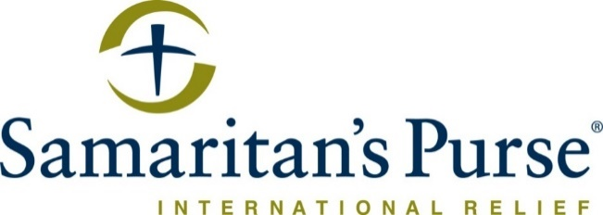

Samaritan’s Purse International Relief

The Office of the United Nations High Commissioner for Refugees (UNHCR)
SSD01/2018/0000000226/001

Project Length: January 1, 2019 – December 31, 2019

Knowledge, Attitudes and Practices (KAP) Report for
Water, Sanitation and Hygiene

Date of Submission: February 30, 2020

Headquarters Contact
Seth Williamson
Regional Director, Northeast Africa
Samaritan’s Purse
801 Bamboo Rd.
Boone, NC 29607
Phone: +1-828-588-2055
Email: SWilliamson@samaritan.org

Field Contact
Mark Bennett
Country Director
Juba Town Road
Hai Cinema, Juba
Central Equatoria, South Sudan
Phone: +211 925 288449
Email: mbennett@samaritan.org

Headquarters Contact
David Philips
Regional Director, Northeast Africa
Samaritan’s Purse
801 Bamboo Rd.
Boone, NC 29607
Phone: +1-828-278-1251
Email: dcphilips@samaritan.org

Field Contact
Mark Bennett
Country Director
Juba Town Road
Hai Cinema, Juba
Central Equatoria, South Sudan
Phone: +211 925 288449
Email: mbennett@samaritan.org

Table of Content
Table of Figures 3
List of Tables 3
Acknowledgements 4
List of Acronyms 4
Executive Summary 5
1.0 Background and context 9
2.0 Introduction 10
2.1 Objectives of the WASH KAP Survey 10
2.2 Methodology 10
2.3 Sample Size Calculation 11
2.4 Household Selection 12
2.5 Survey Respondents 13
2.6 Data Collection, Data Quality and Analysis 13
2.7 Evaluation Team 13
2.8 Selection of Enumerators and Training 13
2.9 Data Management and Analysis 14
2.10 Limitations 14
3.0 Results 14
3.1 Demographics 14
3.2 Water Collection and Storage 15
3.3 Water Safety and Hygiene 18
3.4 Hygiene 20
3.5 Sanitation 21
3.6 Messaging 24
3.7 Non-Food Items (NFIs) 25
3.8 Diarrhea Prevalence, Knowledge and Health Seeking Behavior 27
3.9 Menstrual Hygiene 28
4.0 Discussion 30
4.1 Water Supply and Access 30
4.2 Drinking Water Hygiene 31
4.3 Hygiene 31
4.4Sanitation 31
4.5 Messaging 32
4.6 Non-Food Items 32
4.7 Diarrhea Prevalence, Knowledge and Health Seeking Behavior 32
5.0 Recommendations 33
5.1 Water Supply and Access 33
5.2 Drinking Water Hygiene 33
5.3 Hygiene 33
5.4 Sanitation 33
5.5 Messaging 34
5.6 Non-Food Items (NFIs) 34
5.7 Diarrhea Prevalence, Knowledge and Health Seeking Behavior 34
5.8 Menstrual Hygiene 34
6.0 Conclusion 34

Table of Figures
Figure 1: HH Selection Method Movement 13
Figure 2: Average Quantity of Water per Person per Day 16
Figure 3: Reasons HHs Use Fewer than 15 L per Person per Day 18
Figure 4: Frequency With Which Water Containers Were Cleaned 20
Figure 5: Reasons HHs do not Treat Drinking Water 22
Figure 6: Critical Moments for Handwashing 24
Figure 7: Access to Latrines among Adult Members 26
Figure 8: Facility Type Used by Household Members 26
Figure 9: Materials for the Superstructure of Latrines 28
Figure 10: Materials Used for Making Latrine Slabs 29
Figure 11: Types of NFIs Received by the Respondents 31
Figure 12: HH Satisfaction with Access to NFIs 32
Figure 13: Ways of Getting Diarrhea 34
Figure 14: Methods of Diarrhea Prevention 35
Figure 15: Materials Used during the Last Monthly Period by Surveyed Women 36
Figure 16: Method of Sanitary Hygiene Material Disposal 39

List of Tables
Table 1: Sample Size Calculator for Ajuong Thok 12
Table 2: Sample Size Calculator for Pamir 12
Table 3: Demographic Characteristics of HHs in Ajuong Thok and Pamir Camps 15
Table 4: Container Cleaning Methods 19
Table 5: Surveyed Households that received Health and Hygiene Messages. 24
Table 1: Sample Size Calculator for Ajuong Thok 12
Table 2: Sample Size Calculator for Pamir 12
Table 3: Demographic Characteristics of HHs in Ajuong Thok and Pamir Camps 15
Table 4: Container Cleaning Methods 19
Table 5: Surveyed Households that Rreceived Health and Hygiene Messages. 24

Acknowledgements
Samaritan’s Purse (SP) would like to thank our colleagues at UNHCR and particularly those involved in Water, Sanitation and Hygiene (WASH) programs in Ajuong Thok and Pamir. Samaritan’s Purse is grateful for the participation of the community members of Ajuong Thok and Pamir Camps in the household (HH) survey and focus group discussions (FGDs). Without their input, this assessment would not have been possible. Special thanks to SP WASH staff in Ajuong Thok and Pamir, the monitoring and evaluation (M&E) team, and the enumerators, who put forth great effort to collect data under difficult conditions.

List of Acronyms
CLTS | Community Led Total Sanitation
CRA | Commissioner for Refugee Affairs
DEFF | Design Effect
FGD | Focus Group Discussion
GoSS | Government of South Sudan
HH | Household
HHV | Health and Hygiene Volunteers
IDP | Internally Displaced Person
KAP | Knowledge, Attitudes and Practices
M&E | Monitoring and Evaluation
MDC | Mobile Data Collection
NFI | Non-Food Item
OD | Open Defecation
PLW | Pregnant and Lactating Women
SAF | Sudan Armed Forces
SI | Sampling Interval
SKS | South Kordofan State
SP | Samaritan’s Purse
SPLM-N | Sudan People´s Liberation Movement-North
U5 | Under Five (Years of Age)
UNHCR | Office of the United Nations High Commissioner for Refugees
WMC | Water Management Committee
WASH | Water, Sanitation and Hygiene

Executive Summary
A Knowledge, Attitudes and Practices (KAP) survey was conducted in Ajuong Thok and Pamir Refugee Camps in October 2019 to determine the current Water, Sanitation and Hygiene (WASH) conditions as well as hygiene attitudes and practices within the households (HHs) surveyed. The assessment utilized a systematic random sampling method, and a total of 1,474 HHs (735 HHs in Ajuong Thok and 739 HHs in Pamir) were surveyed using mobile data collection (MDC) within a period of 21 days. Data was cleaned and analyzed in Excel. The summary of the results is presented in this report.

The findings show that the overall average number of liters of water per person per day was 23.4, in both Ajuong Thok and Pamir Camps, which was slightly higher than the recommended United Nations High Commissioner for Refugees (UNHCR) minimum standard of at least 20 liters of water available per person per day. This is a slight improvement from the 21 liters reported the previous year. The average HH size was six people. Women comprised 83% of the surveyed respondents and males 17%. Almost all the respondents were refugees, constituting 99.5% (n=1,466). The refugees were aware of the key health and hygiene practices, possibly as a result of routine health and hygiene messages delivered to them by Samaritan´s Purse (SP) and other health partners. Most refugees had knowledge about keeping the water containers clean, washing hands during critical times, safe excreta disposal and disease prevention.

The following is a summary of major results:

Water Collection and Storage
- 100% of surveyed HHs collected drinking water from a protected/improved source.
- Overall, 47% of surveyed HHs had 20 or more liters of water per person per day.
- The overall average number of liters of water per person per day was 23.40 liters (Ajuong Thok=23.54 liters and Pamir=21.67 liters).
- Almost all those surveyed, 99% (n=1,454) in both Ajuong Thok and Pamir, took 30 minutes or less to reach the primary water source and return to their HHs.
- More than half of the respondents in both locations, 63% (n=925), reported satisfaction (very satisfied, satisfied and neither/neutral) with water access.

Drinking Water Hygiene
- All of the respondents in Ajuong Thok and Pamir reported that they normally cleaned their drinking water collection and storage containers.
- The vast majority of respondents in Ajuong Thok (95%) and Pamir (91%) used a specific product like soap/sabuni budra (detergent), etc. to clean water collection and storage containers.
- Only 2% (n=27) of those surveyed (3% in Ajuong Thok and 0.3% in Pamir) mentioned treating water to make it safe for drinking.

Hygiene
- Over three quarters of those surveyed, 85% (n=625) and 53% (n=394) in Ajuong Thok and Pamir, respectively, had soap available in their HHs at the time of the survey.
- Also, 84% (n=617) and 91% (n=676) of surveyed respondents in Ajuong Thok and Pamir, respectively, could identify at least three critical times for handwashing.
Sanitation
- Close to all respondents (99%) had access to a latrine facility either through owning, sharing or using communal latrines.
- Overall, 57% (n=834) of respondents who mentioned they accessed either HH or communal latrines reported that the facilities provided adequate privacy for them and their HH; 62% (n=448) in Ajuong Thok and 53% (n=386) in Pamir, respectively.
- Overall, 89% (n=1,290) of surveyed respondents who mentioned that they accessed either HH or communal latrines reported using the latrines.
- Also, 99.3% (n=695) of the 700 who mentioned that their children under the age of five (U5) defecated in the open reported that feces were being collected and disposed of in latrines, elsewhere or buried.
- Overall, 17.4% (n=254) of the surveyed HHs had evidence of fecal matter (presence of open defecation [OD]) in the living area within 20 meters of the home (a decrease from 18.5% in 2018).
Messaging
- Overall, 66% (n=976) of those surveyed had received health and hygiene messaging either through home visits by Community Health Workers (CHWs) or through attendance at health or hygiene community meetings; 77% (n=567) and 55% (n=409) in Ajuong Thok and Pamir, respectively.
- Only 14% (n=200) in both Ajuong Thok and Pamir owned a functional radio at the time of the survey.
- Also, 26% (n=386) in both Ajuong Thok and Pamir owned a mobile phone.
Non-Food Items (NFIs)
- Overall, close to one quarter, 24% (n=357), of the HHs in both locations reported receiving at least one WASH non-food item (NFI) during the year from SP, Africa Humanitarian Action (AHA) or International Rescue Committee (IRC).
- Overall, 6.24% (n=92) of the surveyed respondents received water collection and storage containers (buckets and jerry cans) from SP, IRC and AHA.
Diarrhea Prevalence, Knowledge and Health Seeking Behavior
- Overall, 22% (n=262) of the surveyed HHs with children U5 had diarrhea two weeks preceding the survey, in both Ajuong Thok and Pamir.
- All (100%) survey respondents in both locations reported that they knew how to prevent the spread of diarrhea.
- The survey results revealed that 95% (n=698) and 97% (n=720) of the respondents in Ajuong Thok and Pamir, respectively, could identify at least two methods for preventing diarrhea.
Menstrual Hygiene
- At the time of the survey, most (78% [n=936]) of the surveyed women and girls of reproductive age had used reusable cloths, followed by layers of clothes, 21% (n=251); and disposable pads, 20% (n=239); in their last monthly periods..
- Also, 24% (n=151) and 20% (n=119) from Ajuong Thok and Pamir, respectively, would have preferred to have used different materials during their last monthly periods at the time of the survey.
- Overall, 85% (n=1,021) of women in reproductive age disposed of their menstrual hygiene products in latrines, while others washed/reused them, 9% (n=106).
- Before coming to the camps, these women and girls commonly used reusable cloths, 48% (n=577); disposable pads, 28% (n=341); layers of clothes, 26% (n=317); and reusable pads, 15% (n=179). Others also used cotton wool, layers of a certain tree bark and soap.
Recommendations
Water Supply and Access
- Increase the number of water collection and storage containers at the HH level to enable members to meet the recommended amount of water consumed per person per day.
- Maintain water supply quantities at existing water points and provide timely response in case of any breakdowns.
- Educate water users on the importance of getting clean and safe water, as the majority claim about the smell of chlorine in water.

Drinking Water Hygiene
- There is a need to carry out more hygiene promotion messaging on protecting stored water, as 23% of respondents were observed to dip fingers in the water as they drew water into a cup.
Hygiene
- Distribute more soap, majority who did not have soap readily available stated that it had been used up. Others also expressed that they had a large number of family members; when possible, soap distribution should factor in family size.
- In the long term, a strategy is needed to wean off heavy reliance of basic provisions like soap, through empowerment and market growth.
- Intensify on health promotion messaging that encourages people to build and use the handwashing facilities.
Sanitation
- Improve on latrine coverage targeting 85%, as currently only 62% of the surveyed respondents own a latrine facility. Also, intensify health promotion messaging on disease paths.
- Routinely, consult with refugees to better latrine design/positioning to improve usage, privacy and structural designs. Latrines must be designed factoring in users’ beliefs and behavior.
- Continue sensitizing communities on the importance of using latrines; also, target new arrivals facing adaptation challenges and host community members.
- Encourage small children whose parents are away to use the latrines, accompanied perhaps by their older brothers or sisters or neighbors who can teach them until they learn proper latrine use.
- Distribute lids/drop-hole covers or promote their use. This is important to keep away flies.
- Explore promotion of community-driven approaches that address behaviors and practice, such as Community Led Total Sanitation (CLTS), starting with an in-depth feasibility study.
- Explore further the potential of using more locally available materials for latrine construction, for the sustainability of the practice in all aspects while retaining standard approved technical design.
Messaging
- Focus on home visits and communal gatherings with innovative messaging when discussing health and hygiene.
- Revise the health promotion strategy targeting community members who have access to radio since it was reported to be a highly favored medium.
Non-Food Items (NFIs)
- Hold more engagements with beneficiaries to provide local solutions to the areas with which they are dissatisfied concerning NFIs.
Diarrhea Prevalence, Knowledge and Health Seeking Behavior
- Strengthen WASH activities and intensify on health promotion messaging on diarrhea.
Menstrual Hygiene
- Increase and adapt distribution of menstrual supplies relating to what the women and girls favor most, to cover the unmet need.

1.0 Background and context
Samaritan’s Purse International Relief (SP) has been working in South Sudan for over two decades, serving the most vulnerable populations in emergency and conflict settings. Samaritan´s Purse has been serving refugees fleeing from the fighting in South Kordofan State (SKS) since 2011. Long standing friction in Southern SKS of Sudan resulted in an eruption of violence, which turned into large-scale fighting in the Nuba Mountain region of SKS between the Sudanese Armed Forces (SAF) and the Sudan People´s Liberation Movement-North (SPLM-N). This outbreak of war resulted in the creation of a spontaneous refugee settlement in Yida, which is located in Jau County, Ruweng State in South Sudan.

The geographical and security context of the spontaneous Yida Refugee Settlement compromised the protection of refugees residing in the settlement, according to UNHCR. This was due to Yida’s proximity to the contested border point of Jau and frequent reports of forced recruitment of refugees by armed groups. Additionally, there was a risk of refugees becoming a military target for SAF, Yida´s militarization due to the mixed character of influx (civilian asylum-seekers, combatants and former combatants) and other associated protection concerns which fundamentally questioned its suitability as a refugee site.

Owing to the above factors, the Government of South Sudan (GoSS) issued a policy limiting service provision in Yida to life saving services only, from the onset of humanitarian interventions in Yida. However, GoSS stated that other services would be made available in the officially recognized refugee camps of Ajuong Thok and Pamir situated in Jamjang County, both established as alternative sites to host refugees in 2013 and 2016, respectively. According to UNHCR, the population of Ajuong Thok Camp in September, 2019 was 39,309 (7,996 HHs) and the population in Pamir was 34,097 (8,008 HHs).
In 2019, SP implemented a WASH program in both Ajuong Thok and Pamir Refugee Camps. The WASH program focused on rehabilitation and maintenance of water systems, solarization of boreholes, and solid waste disposal. Project activities were specifically designed to include borehole maintenance, water-quality testing and water treatment, establishment of water management committees (WMCs) and training of pump operators, construction of gender-sensitive emergency latrines in public areas and market places, construction of HH latrines and decommissioning of emergency latrines.

Samaritan´s Purse, AHA in Ajuong Thok and IRC in Pamir implemented hygiene promotion activities including distribution of NFIs, establishment of health and hygiene volunteers (HHVs), hygiene campaigns, and construction of handwashing facilities. Environmental health activities included solid waste management trainings, community-led debris clean-ups, construction of refuse pits, and the installation and maintenance of water drainage systems and established water points/tap stands.

2.0 Introduction
This section highlights the steps that were taken to conduct the WASH KAP survey for UNHCR in Ajuong Thok and Pamir outlined below. This includes the overall objective, survey methodologies, sample frames, data collection, entry and analysis. The assessment was completed in November 2019. Samaritan´s Purse is currently providing water supply, maintenance and sanitation services while the other partners, AHA and IRC, are implementing the health and hygiene component.

2.1 Objectives of the WASH KAP Survey
The objective of the survey was to evaluate the knowledge, attitudes and practices related to WASH of refugees living in both Ajuong Thok and Pamir Camps. Questions were focused on water source, collection, storage, hygiene and sanitation. The information gathered will be used to inform SP and other WASH partners’ future programming in the camps.

2.2 Methodology
The survey population for the KAP assessment consisted of the affected population (children, women and men) residing in Ajuong Thok and Pamir Camps in Jamjang County. Quantitative data was obtained through HH structured questionnaires and qualitative information through focus group discussions (FGDs). Samaritan´s Purse employed a multistage sampling where the primary sample unit was selected systematically. At the first stage, Jamjang County was broken up into two clusters based on naturally occurring administrative areas, Ajuong Thok and Pamir Camps. At the second stage, since all clusters were easily accessible, each cluster was sampled within Ajuong Thok and Pamir Camp, respectively. At the third stage, HHs within the clusters were selected using systematic random sampling.
Sample size was determined as outlined below. All blocks in each of the two refugee camps were visited.

2.3 Sample Size Calculation
The sampling unit was HHs. The population of Ajuong Thok Camp was 39,309 (7,996 HHs) and the population in Pamir was 34,097 (8,008 HHs). Ajuong Thok has 68 occupied blocks and Pamir 54. Sample size for each camp was determined independently.
The sample size for the Standardized WASH KAP Survey was calculated using the recommended (and widely used) formula below:

𝑛= [(t² x p x q)/d²]]* 𝑑𝑒𝑓𝑓
Where:
- n = the calculated sample size
- t = the error risk parameter (which is 1.96, for a confidence interval of 95%)
- p= the expected prevalence (which is 0.5 for 50% prevalence - in normal situations)
- q = 1-p, the expected non-prevalence (which is 50% in normal situations)
- d= the relative desired precision (for simple/systematic random sampling, 5% precision in normal situations)
- deff = the design effect in case of cluster sampling (which is 2 for cluster sampling)
Using the formula, the calculated sample size was 769 per location. The adjusted sample size with an anticipated non-response rate of 5% was 739 in each location, using a customized Excel template developed by UNHCR.
For instance, the calculated sample size was 769 HHs and the total number of HHs was 7,996 in Ajuong Thok; thus, the adjusted sample size with an anticipated non-response rate of 5% was 739 in Ajuong Thok, as shown below.
Table 1: Sample Size Calculator for Ajuong Thok
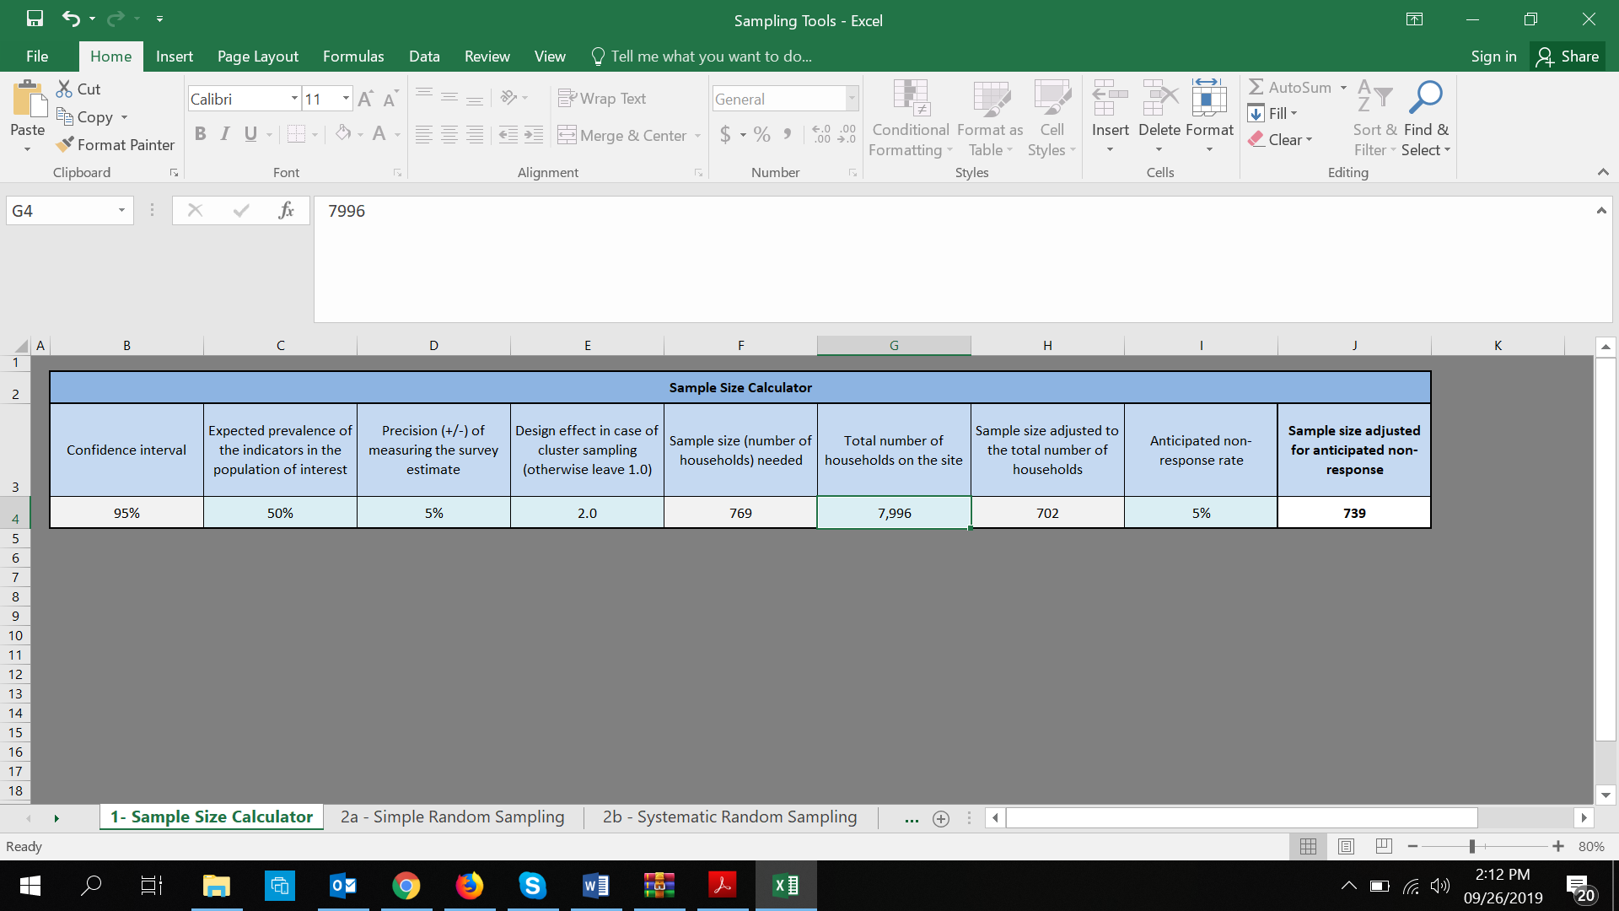
A similar step was repeated for Pamir, the calculated sample size was 769 HHs and the total number of HHs was 8,008 in Pamir; thus, the adjusted sample size with an anticipated non-response rate of 5% was 739 in Pamir, as shown below.
Table 2: Sample Size Calculator for Pamir
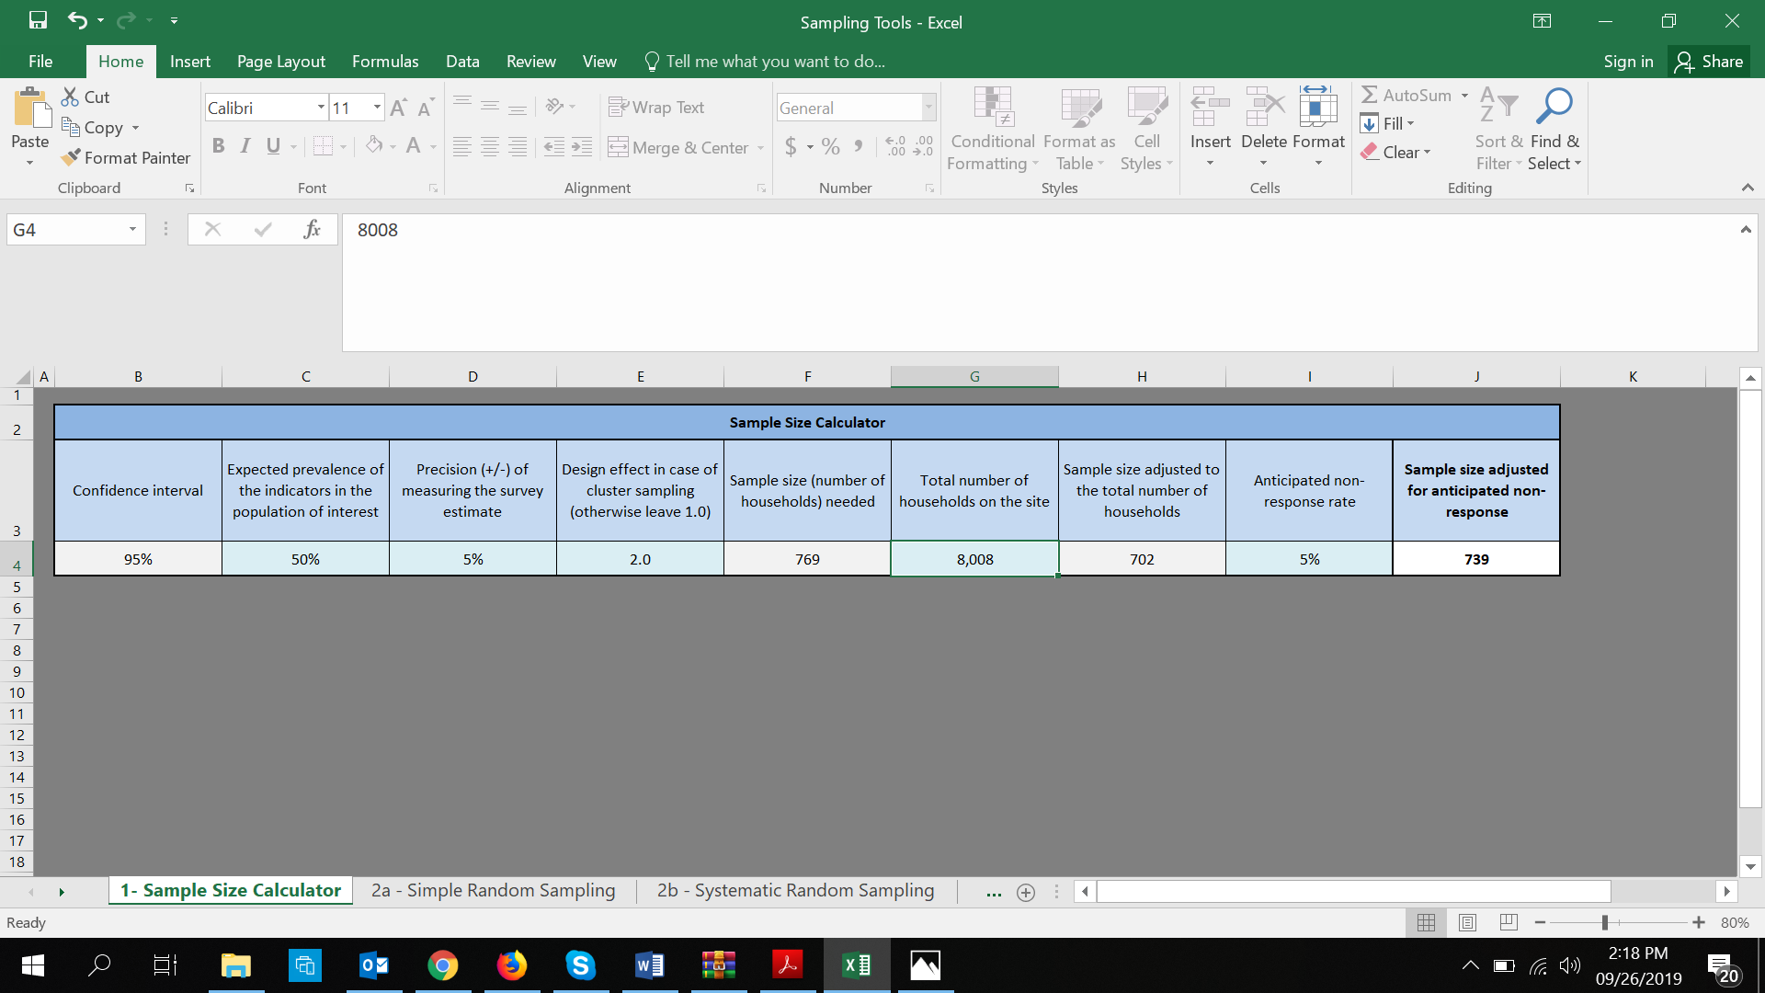

2.4 Household Selection
Households were selected using systematic random sampling. Enumerators systematically walked through the camp block by block, row by row, in such a way as to pass each HH. Within blocks, enumerators started at one corner, then systematically used the sampling interval as they walked up and down each of the rows throughout the block, covering every block in Ajuong Thok and Pamir.
In each location, the first HH sampled in a block was generated using an Excel tool customized by UNHCR which generated a Random Start and Sampling Interval.

Figure 1: HH Selection Method Movement
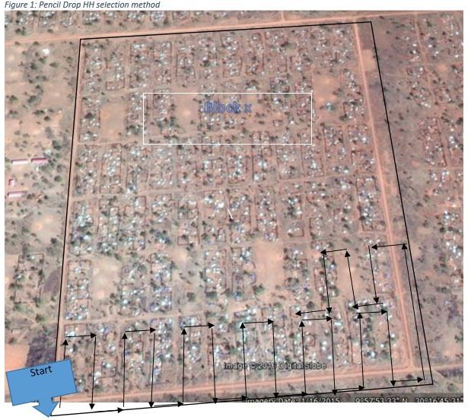

2.5 Survey Respondents
The preferred respondents were female heads of HH. If this person was not available, another adult (over 15 years of age) with knowledge of the HH´s practices was surveyed. If no one qualified to answer the survey was home, enumerators would move to the next HH following the sampling interval.

2.6 Data Collection, Data Quality and Analysis
Mobile Data Collection was used to collect the quantitative data using Apple iPad tablets fitted with the iFormBuilder software platform. All questionnaires were written in English, although the interviews were conducted in Arabic, the language most widely spoken by the respondents and participants. During training, question translation was mastered to ensure translation consistency among the enumerators. A questionnaire pretest was done with some HHs to ascertain that the enumerators had understood the questionnaires; any issues emerging were addressed.
Data collection occurred over a period of 18 days. Focus group discussions included both male and female members of AT and Pamir, involving at least 72 people (36 males and 36 females). The collected data was verified on a daily basis prior to data syncing onto the cloud server, and feedback was given to enumerators before beginning data collection the following day. Random spot checks were made on data that was synced and cleaned, to ensure consistency and accuracy before beginning analysis.

2.7 Evaluation Team
The evaluation team consisted of both SP and UNHCR technical staff who provided overall oversight in the management and execution of the WASH KAP Survey. The overall lead was the SP National M&E Manager assisted by the M&E Training Coordinator, M&E Officer and project staff. In addition, project staff played a key role in communicating project related challenges, new interventions introduced based on previous recommendations and other contextual issues which needed to be considered during the evaluation. Overall oversight was provided by UNHCR to ensure that the evaluation was conducted in line with the UNHCR Standard Guidelines for WASH KAP Surveys.

2.8 Selection of Enumerators and Training
- Due to recurrent incidences related to employment and its political implications, and given that the Jamjang population is a mixture of refugees and host community members, the selection had to be handled sensitively by the Human Resources (HR) Department and local leadership since refugee enumerators were favored because they speak the Arabic language which is understood by the survey respondents than their counterparts from the host community..
- Enumerators applied in response to a job advert or through a recommendation, and they were tested and their performance was determined before selection. The test assessed their ability to conduct the assignment. A pool of secondary candidates were retained on a waiting list to replace or support the hired team. Great consideration was given to previous enumerators who excelled while working with SP on previous similar surveys.
- Fifteen enumerators were recruited and trained for the exercise. Three days of training were given to these previously experienced enumerators, focusing on the data collection protocol, interviewing skills, and fundamental concepts and vocabulary. Review and translation of the questionnaire formed the main part of the training, as well as an important emphasis on the proper use of the technology, skip patterns, effective probes, etc., to ensure the accuracy and consistency of the data collected. Enumerators were trained on how to use the tools and how to identify and sample HHs for interview, and underwent a thorough pretesting exercise.
In general, most of the recruited enumerators were female, because more female respondents were targeted since they were more knowledgeable of the HH practices. Since an element of menstrual hygiene was included in the survey, past experience indicated that it was prudent to use female enumerators, as the female respondents could speak freely to female enumerators.

2.9 Data Management and Analysis
The data was collected using iFormBuilder and uploaded to the server at the end of each day. The iFormBuilder generated a Microsoft (MS) Excel spreadsheet dataset which was then cleaned and analyzed using MS Excel.
Given that SP, IRC and AHA are currently implementing WASH programming in Ajuong Thok and Pamir, the assessment data collected in Ajuong Thok and Pamir will not only be the endline for UNHCR 2019 programming but also the baseline for the 2020 programming.

2.10 Limitations
- Data collection occurred during groundnut harvesting for targeted HHs, as well as some periods of food distribution in both Ajuong Thok and Pamir, leading to many female heads of HH not being available in their homes at the time of the survey; visits were rescheduled by the enumerators.
Some blocks of Ajuong Thok and Pamir were found to be unoccupied. This challenge was handled by skipping these blocks and replacing them systematically.

3.0 Results

3.1 Demographics
In Ajuong Thok, 735 HHs were selected; 15% (n=107) and 85% (n=628) were male and female respondents, respectively. In Pamir, 739 HHs were selected; 19% (n=138) and 81% (n=601) were male and female respondents, respectively. Overall, 17% (n=245) and 83% (n=1,229) of the total respondents from both locations were male and female, respectively. Almost all of the surveyed respondents were refugees (99% [n=1,466]). All the selected respondents voluntarily participated in an interview.

Table 3: Demographic Characteristics of HHs in Ajuong Thok and Pamir Camps
Characteristic | Ajuong Thok | Pamir | Overall
Sex
Male | 107 (15%) | 138 (19%) | 245 (17%)
Female | 628 (85%) | 601(81%) | 1,229 (83%)
Residence Status
Refugee | 727 (99%) | 739 (100%) | 1,466 (99%)
Host | 8 (1%) | 0 (0%) | 8 (1%)
Hosting Refugees
Yes | 148 (20%) | 63 (9%) | 211 (14%)
No | 587 (80%) | 676 (91%) | 1,263 (86%)
Average HH Size
Members | 6 | 6 | 6
HH Vulnerability
Yes | 95% (696) | 94% (691) | 94% (1,387)
Category of Vulnerabilities
Children U5 | 79% (578) | 80% (593) | 79% (1,171)
Pregnant/Lactating | 60% (440) | 64% (472) | 62% (912)
Person with Disability | 15% (111) | 15% (109) | 15% (220)
Adult over 60 Years Old | 14% (102) | 14% (102) | 14% (102)

The average number of members in surveyed HHs who spent the night preceding the survey at the respondents’ HHs was six, while for children U5 it was two.
Of the surveyed respondents, 95% (n=696) in Ajuong Thok and 94% (n=691) in Pamir had at least one vulnerable person in their HH who was either a child U5, a pregnant or lactating woman (PLW), a person with disability or an adult over the age of 60. The most prevalent category in surveyed HHs reporting vulnerability was children U5, 80% (n=1,171), followed by PLWs, 62% (n=912). Finally, 14% (n=211) of the surveyed HHs reported hosting non-household members at the time of the survey.

3.2 Water Collection and Storage
Percentage of HHs collecting all domestic water for drinking, cooking and hygiene from improved water sources.
For all the respondents (100%), the main source of drinking water was an improved source; all respondents in both locations mentioned public taps/standpipes. This meets the UNHCR post emergency standard of >=95%. None of the respondents used an unsafe source for drinking water as either their main or second most used source. During FGDs, all eight groups mentioned a constant supply of safe water and easy access by their HHs throughout the year.

One participant stated: “There is constant flow of water across all the blocks and everyone can access water anytime.” Participants said this was because of timely repairs undertaken by SP to ensure a fulltime water supply. Public taps/standpipes are being maintained by SP, including repairs, upgrade, treatment and water quality tests.

Average number of liters of water available per person per day.
To estimate the average HH water consumption per person per day, respondents were asked to show enumerators the containers they normally used for collecting and storing water. Only containers that were in good condition at the time of the survey were considered. Respondents were then asked which of the presented containers were used to fetch water for drinking, cooking and personal hygiene and the quantity of water collected the day prior to the survey (indicated by showing the size of the water carrying containers they had used and the number of times they had collected water with each of these containers).

Overall, 47% (n=694) of respondents had 20 or more liters of water per person per day; 55% (n=406) and 39% (n=288) in Ajuong Thok and Pamir, respectively. The overall average number of liters of water per person per day was 23.40 liters (Ajuong Thok=23.54 liters and Pamir=21.67 liters). This indicates that SP is meeting the UNHCR minimum standard for output of more than 20 liters per person per day.
Figure 2: Average Quantity of Water per Person per Day

Overall, 68% (n=996) (76% [n=555] in Ajuong Thok and 60% [n=441] in Pamir) of the surveyed HHs used 15 liters or more of water per person per day.
For HHs that used less than 15 liters of water per person per day, main reason given was that they did not have enough containers to either store or carry water. Of the 478 surveyed HHs that consumed less than 15 liters of water per person per day, 87% (n=418) mentioned the lack of containers. This can also be explained by the fact that the average number of containers per HH was three in both locations (Ajuong Thok=3 and Pamir=2).
Figure 3: Reasons HHs Use Fewer than 15 L per Person per Day

The problem of water collection and storage containers was further compounded by the fact that only 24% (n=357) of the HHs in both locations reported that they had received at least one WASH NFI during the current year from SP, AHA or IRC. Of the respondents who reported receiving NFIs, 17% received buckets and 17% received jerry cans in Ajuong Thok. In Pamir, 16% received buckets and 17% received jerry cans. Overall, only 6.24% (n=92) of the surveyed respondents mentioned that they received water collection and storage containers (buckets and jerry cans) from SP, IRC and AHA.
A female participant in an FGD said: “We do not fetch enough water because the containers are not enough.” Other recurrent themes in FGDs related to reasons for collecting less water had to do with low water pressure at certain times of the day, such as in the morning, and difficulties accessing water from other blocks when their own taps were broken.

Of the surveyed HHs, 76% had at least 10 liters of potable water storage capacity in both camps.

Percentage of households with a 30 minute or less average round trip time to collect water.
Access to water within 30 minutes or less, round trip, has been met in accordance with UNHCR standards of at least 85%. Overall, 99% (n=1,454) of the surveyed HHs took 30 minutes or less to reach the primary water source and return to their HHs. Both Ajuong Thok and Pamir had similar results of 99% (n=726) and 99% (n=728), respectively.

The average time for all round trips to the water source was six minutes, implying a high level of water access. Regarding water access, 62.8% (n=925) of the surveyed respondents in both locations reported they were very satisfied, satisfied and neither/neutral with water access.

Most of the surveyed respondents reported that adult females were collecting water, 73% (n=1,077), followed by children aged 11-18 years, 18% (n=268).

3.3 Water Safety and Hygiene
Respondents were asked for a small sample of drinking water to understand how people drew water from storage containers. A total of 1,346 respondents were asked to present drinking water to the enumerators in a suitable container. Out of 913 surveyed respondents who brought drinking water in a cup, 87% (n=796) were observed to have drawn water from containers without their fingers touching the water, meaning 13% did. The practice of drawing drinking water can expose safe drinking water to recontamination if fingers touch the water, especially if the hands are unwashed.
Percentage of households cleaning their water storage and collection containers.
With regard to cleaning water containers, all of the respondents (100%) in both Ajuong Thok and Pamir reported that they normally cleaned their drinking water collection and storage containers. Of those, 59% (n=432) from Ajuong Thok and 68% (n=503) from Pamir, respectively, indicated that they normally did it every time their containers were used. Others cleaned their containers at least once a week, as shown in the figure below.
Figure 4: Frequency With Which Water Containers Were Cleaned

The most reported method for cleaning the drinking water containers in both Ajuong Thok (95%) and Pamir (91%) was using a specific product like soap/sabuni or budra (detergent). Other methods included using sand and ash, using a piece of tissue and rinsing them with only water, as shown below.

Table 4: Container Cleaning Methods
Method of cleaning drinking water containers | Ajuong Thok | Pamir | Overall
Wash them with a specific product like soap, sabuni, budra, etc. | 697 (95%) | 673 (91%) | 1370 (93%)
Rinse them with water | 8 (1%) | 30 (4%) | 38 (2%)
Wash them with a piece of tissue | 5 (1%) | 5 (1%) | 10 (1%)
Wash them using rocks and shaking | 11 (1%) | 20 (3%) | 31 (2%)
Sand and ash | 14 (2%) | 11 (1%) | 25 (2%)

Percentage of households using any water treatment method.
On average, only 2% (n=27) of those surveyed (3% in Ajuong Thok and 0.3% in Pamir) mentioned treating water to make it safe for drinking. Respondents from both locations (Ajuong Thok [n=25] and Pamir [n=2]) who mentioned treating water to make it safe before drinking were asked what methods they used. The most common methods in both locations were the use of Pur, boiling and filtering .
Reasons for not treating drinking water.
Most of the respondents, 90% (n=1,332), believed that the water they collected was sufficiently clean and did not require treatment. The water SP provides is treated with chlorine and the free residual chlorine further protects water from being contaminated The other reasons mentioned by the respondents for not treating drinking water are shown in the figure below.

Figure 5: Reasons HHs do not Treat Drinking Water

3.4 Hygiene
Of those surveyed, 85% (n=625) and 53% (n=394) in Ajuong Thok and Pamir, respectively, had soap available in their HHs at the time of survey. Of those who had soap, the majority, 99% (n=1,005), (98% [n=612] in Ajuong Thok and 100% [n=393] in Pamir) obtained soap from non-governmental organizations (NGOs), followed by purchases from the shop/market, 1% (n=12).
Respondents who reported that their HHs did not have soap (n=455) at the time of the survey were asked the main reason for the absence of soap; 93% (n=424) said they ran out of soap, 3% (n=14) mentioned they were waiting for the next distribution and 1% (n=4) reported they could not afford it.
Also, 84% (n=617) and 91% (n=676) of respondents in Ajuong Thok and Pamir, respectively, could identify at least three critical times for handwashing. The most identified critical time for handwashing was after defecation, 91% (n=1,338). The least identified moments were after handling a child's stool/changing a nappy/ cleaning a child's bottom, 9% (n=137), as shown below:

Figure 6: Critical Moments for Handwashing

Of the respondent HHs in both locations, 38% (n=559) were observed to have a specific handwashing device/station such as a bouta, basins/buckets, ibrick, or small jerry cans at home. Of the 559 respondents who reported and were observed to have a handwashing device/station, 70% (n=389) of their handwashing devices/stations had water in them. The presence of soap or any handwashing materials in the handwashing areas for the 559 respondents who reported and were observed to have a handwashing device/station was at 48% (n=268).

3.5 Sanitation
Percentage of households using an improved sanitation facility.
When asked where HH members usually go to defecate, excluding children U5, 83% (n=1,225) reported that they used HH latrines, 16% (n=232) used communal latrines and 1% (n=14) reported OD. Overall, 99% (n=1,457) usually defecated in a toilet facility (HH and communal).

Figure 7: Access to Latrines among Adult Members
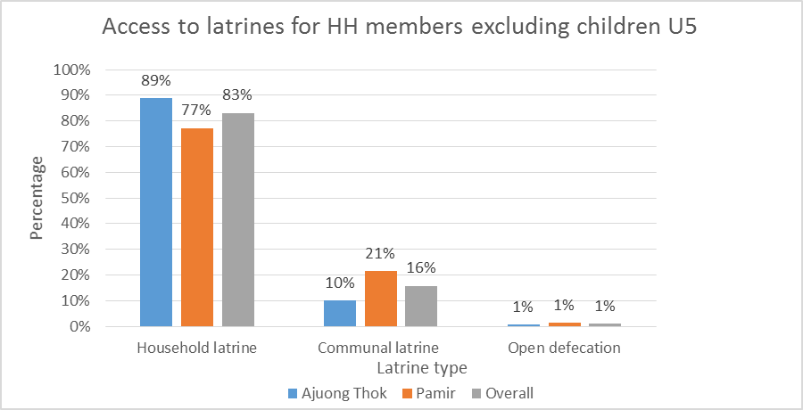
Respondents were further asked the type of facility which their HH members usually used. Overall, 62% (n=907) (70% [n=518] in Ajuong Thok and 53% [n=389] in Pamir) reported that they used a single HH facility (used only by one HH). This is similar to 63% who reported using a single HH facility during a recently concluded latrine census by SP. Also, 29% (n=432) reported they used a shared facility, 8% (n=118) used a communal facility and 1% (n=17) usually defecated using other means such as OD and dig and bury, as shown below.

Figure 8: Facility Type Used by Household Members
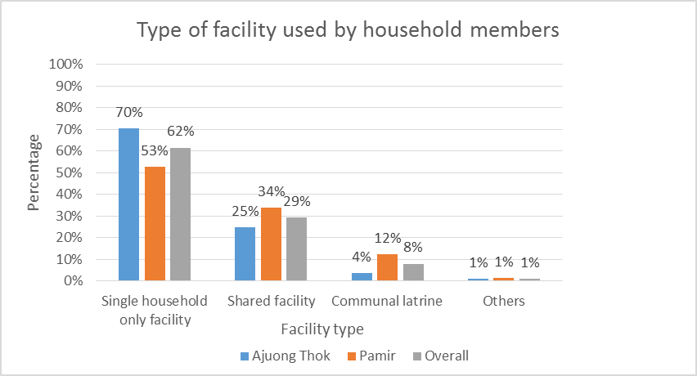

For the HHs who said they shared a HH latrine facility (29%), these were shared by an average of two (12 users) and three HHs (18 users) in Ajuong Thok and Pamir, respectively, which is within UNHCR standards of one latrine not being shared by more than 20 people.
Overall, 57% (n=834) of the respondents reported that their latrine facilities provided them and their HH members adequate privacy; 62% (n=448) and 53% (n=386) in Ajuong Thok and Pamir, respectively. The reasons for lack of privacy were reported as poor or damaged infrastructure/doors, missing or nonfunctional locks, and the latrines being too close to the house.
Overall, most (89% [n=1,290]) of the respondents who mentioned they accessed either HH or communal latrines reported they were using the latrines. During FGDs, participants also mentioned challenges with the previous latrine design and said it made the latrine too narrow, and the latrine lacked a vent pipe. Some participants also said the latrines were too close to the HHs.
Regarding the materials used for construction, respondents mentioned that the main materials used for the superstructure were bricks, followed by plastic sheeting, as shown below:

Figure 9: Materials for the Superstructure of Latrines
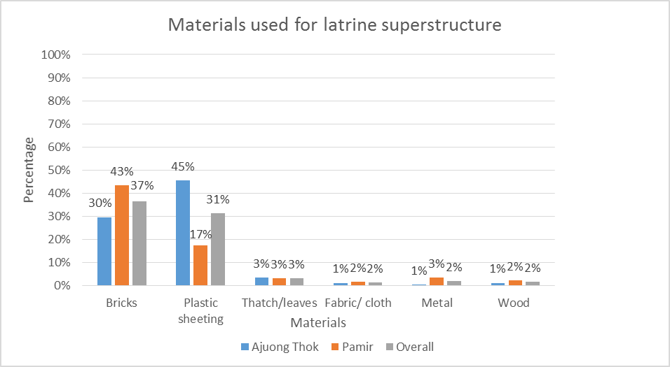Regarding the materials used for construction of the slabs, respondents reported that their latrine slabs were made of plastic, followed by concrete, as shown below:

Figure 10: Materials Used for Making Latrine Slabs
More than half (56% [n=819]) of the respondents who had access to either HH or communal latrines were observed to have complete and clean latrines. This number is similar to that found during a recent SP latrine census (62.2%.%).
Percentage of households practicing open defecation.
Overall, 17.4% (n=254) of the surveyed HHs had evidence of fecal matter (presence of OD) in the living area within 20 meters of the home (18.5% in 2018). The OD rate in Ajuong Thok (15.5% [n=114]) was lower than that in Pamir (18.9% [n=140]). During FGDs, participants were asked their feelings about OD. All the groups attested to the dangers of OD and said it led to the spread of more diseases, many adding that OD was being done by children. Some participants explained that OD persists in communities because during most of the average day, adults leave the homestead for different daily economic activities, and this leads to children’s feces staying on the compounds in the open, for extended periods of time.
This may resonate with other survey findings about the disposal of children´s feces. Of surveyed HHs with children U5, 60% (n=700) reported their children U5 usually defecated in the open. However, when asked what was done with the children’s feces, almost all, 99.3% (n=695), said that the feces was collected and disposed of in latrines, or buried in the ground around the homestead or elsewhere away from home.

3.6 Messaging
Survey respondents were asked whether they or anyone in their HHs had received hygiene promotion messaging within the year. Overall, 66% (n=976) had received this messaging either through home visits by the CHWs or through attending health or hygiene community meetings. The percentage reported was relatively higher in Ajuong Thok, 77% (n=567), than in Pamir, 55% (n=409). Samaritan´s Purse does not carry out this activity, as it is implemented by other partners, namely IRC (Ajuong Thok) and AHA (Pamir).

Table 5: Surveyed Households that Received Health and Hygiene Messages
 | Ajuong Thok | Pamir | Overall
Received a Visit from a CHW to Discuss Health or Hygiene | 477 (65%) | 318 (43%) | 795 (54%)
Attended a Health or Hygiene Community Meeting | 436 (59%) | 261 (35%) | 697 (47%)
Received Health and Hygiene Promotion Messages | 567 (77%) | 409 (55%) | 976 (66%)

Most(54% [n=795]) received messaging through the home visit from a CHW to discuss any health or hygiene related issues. Also, 47% (n=697) in both locations received the same message in a community group gathering.
The level of literacy among the surveyed respondents was low, with only 25% (n=364) reporting they were able to read and write easily. Similarly, 13% (n=189) mentioned they could read and write but with some difficulty.
Asked for possession of another communication medium within the HH, 14% (n=200) owned a functioning radio at the time of the survey, overall (13% [n=98] in Ajuong Thok and 14% [n=102] in Pamir, respectively).
Meanwhile, mobile phone possession within the HH was 26% (n=385) overall, with 37% (n=273) in Ajuong Thok and 15% (n=112) in Pamir. This preliminarily shows that home visits (54%) and community meetings (66%) were still the most common means of reaching the public with health information and education.
However, when asked about the best preference for communication of health messaging, almost half of the respondents preferred the radio, 47% (n=690), followed by home visits, 28% (n=405) and then community meetings, 15% (n=216). The fact that only 14% of the surveyed HHs had a functioning radio, and yet it is a highly preferred communication medium, seems to indicate that information transmitted by radio may have a wider circulation perhaps through physical conveyance of the message by those with radios to others It is worth investigating if the 26% who own a mobile phone can access a radio through it. A radio tuner ability is a common feature on most affordable mobile phones around East Africa.

3.7 Non-Food Items (NFIs)
During the survey, 24% (n=357) of the HHs in both locations reported receiving at least one WASH NFI during the year from SP, AHA or IRC.
Of the respondents who reported receiving NFIs in Ajuong Thok, 84% (n=201) received soap and 63% (n=152) received other NFIs such as blankets, mosquito nets, sanitary pads, plastic sheets and utensils, etc. In Pamir, 78% (n=91) received soap and 60% received other NFIs such as blankets, mosquito nets, sanitary pads, plastic sheets and utensils, etc., as shown in the figure below

Figure 11: Types of NFIs Received by the Respondents
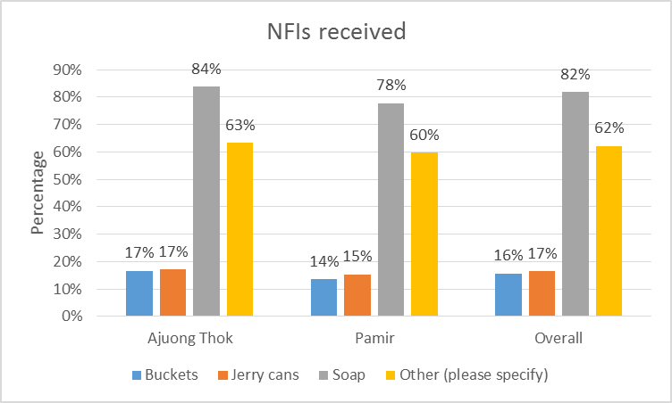
Overall, 6.24% (n=92) of the surveyed respondents received water collection and storage containers (buckets and jerry cans) from SP, IRC and AHA.
Survey respondents were also asked how they felt about the NFI distribution methods used by partners in the the two camps, and only 39.3% (n=580) rated the distribution method as suitable (very good, good and reasonable).
Figure 12: HH Satisfaction with Access to NFIs

When asked how satisfied their HHs were with access to NFIs (soap, jerry cans, buckets), only 24.8% (n=365) reported they were satisfied, neutral and very satisfied. We assumed this is meant as a call for more NFI distributions.

3.8 Diarrhea Prevalence, Knowledge and Health Seeking Behavior
Overall, 22% (n=262) of the surveyed HHs with children U5 had diarrhea in the two weeks preceding the survey; 21% (n=122) in Ajuong Thok and 24% (n=140) in Pamir, respectively. Diarrhea was defined as the passage of three or more loose or liquid stools per day (or more frequent passage than is normal for the individual). These findings may resonate well, given that Pamir had lower latrine coverage and higher OD rates than Ajoung Thok.
When respondents were asked ways in which people can get diarrhea, most mentioned from flies, 88% (n=1,299), through contaminated water, 68% (n=1,008), etc., as shown below:
Figure 13: Ways of Getting Diarrhea

Percentage of respondents who can identify at least two ways to prevent diarrhea.
All (100%) survey respondents in both locations reported that they knew how to prevent the spread of diarrhea. Most of the survey respondents, 78% (n=1,155), mentioned that covering food is one of the ways to prevent diarrhea. Other prevention methods mentioned included washing hands with soap and water, 72% (n=1,058), cooking food well, 64% (n=949), etc.
Close to all the respondents could identify at least two ways of preventing diarrhea. The survey results revealed that 95% (n=698) and 97% (n=720) of the respondents in Ajuong Thok and Pamir, respectively, could identify at least two methods for preventing diarrhea. More than three-fourths of the respondents (79% [n=581] and 80% [n=593] in Ajuong Thok and Pamir, respectively) identified at least three or more methods of diarrhea prevention, as shown below:

Figure 14: Methods of Diarrhea Prevention

3.9 Menstrual Hygiene
In Ajuong Thok and Pamir, women and girls of reproductive age were surveyed about their menstrual hygiene. They were asked the specific materials they used during their last monthly period. Most, 78% (n=936), used reusable cloths; followed by layers of underwear 21% (n=251); and then disposable pads, 20% (n=239). Other products mentioned included cotton wool, layers of a certain tree bark and soap.

Figure 15: Materials Used during the Last Monthly Period by Surveyed Women

When the women and girls who participated in the survey were asked if they would have rather used different materials in their last period, 22% from both camps agreed. Of these, 52% (n=140) preferred to have used disposable pads, followed by reusable pads, 37% (n=101); reusable cloth, 29% (n=77); and, finally, layers of underwear, 11% (n=31), in both camps.
When asked the material they used for menstrual hygiene before coming to the camp, 48% (n=577) used reusable cloth, 28% (n=341) disposable pads, 26% (n=317) layers of cloth and 15% (n=179) reusable pads. Other products mentioned included cotton wool, layers of a certain tree bark and soap.
More broadly, this paints a picture of lack of access to sanitary materials. While partners do occasionally distribute hygiene kits, they are insufficient for the high demand. .
Disposal of menstrual hygiene materials
In both camps, the majority of women and girls, 85% (n=1,021), reported that they disposed of their menstrual hygiene products in their HH latrines, followed by washing/reusing them, 9% (n=106), and burning them, 1% (n=8). Three percent did not know how to dispose of the materials, while the most common “other” way mentioned was disposal in a neighbor’s latrine. No respondent mentioned “trashing” or disposing of sanitary materials “in the open.” This shows both sensitivity and possible knowledge on proper disposal of sanitary materials.

Figure 16: Method of Sanitary Hygiene Material Disposal

4.0 Discussion

4.1 Water Supply and Access
Samaritan´s Purse, with support from UNHCR, implemented a WASH program in 2019. The major program objective was to increase and maintain the supply of potable water in Ajuong Thok and Pamir Refugee Camps by producing water from deep hybrid boreholes, piping it into the blocks and collecting it from the nearby tap stands. Samaritan´s Purse conducts water quality testing at boreholes and at HHs.
All respondents in both camps cited public taps/standpipes as the main source of their HH drinking water. None of the respondents surveyed used an unsafe source for drinking water. During FGDs, all eight groups mentioned receiving constant water flow all year, meaning all-year-round water access. However, concerns were raised about the water flow in the morning, stating that the pressure was normally weak. Also, the smell of chlorine in the water came up again, three years running.
The average number of liters of water per person per day was 23.40 liters (Ajuong Thok=23.54 liters and Pamir=21.67 liters), implying that SP met the UNHCR production standard for output (20 liters or more per person per day). A slight increment in the proportion of surveyed HHs consuming 20 liters of water per person per day was registered from 42% in 2018 to 55% in 2019 in Ajuong Thok, whereas Pamir registered a slump from 45% in 2018 to 39% in 2019.
Of those who fell shortshort, the main reason HHs gave for using fewer than 15 liters of water per person per day was that they did not have enough containers to either store or carry water. Of the 478 surveyed HHs that did not meet Sphere standards (consumed fewer than 15 liters of water per person per day), 87% (n=418) mentioned lack of containers. This can also be explained by the fact that the average number of containers per HH was two to three in both locations (Ajuong Thok=3 and Pamir=2). Pamir did not meet the Sphere standard of five containers for collecting and storing water.
The problem of water collection and storage containers was further compounded by the fact that only 6.24% (n=92) of the surveyed respondents received water collection and storage containers (buckets and jerry cans) from SP, IRC and AHA in both locations during the year. Of the surveyed HHs, 76% had at least 10 liters of potable water storage capacity in both camps, which is below the standard UNHCR post-emergency standards of 80%.

The UNHCR standard of a 30 minute or less round trip to access water has been met, as 99% (n=1,454) (99% [n=726] and 99% [n=728] in Ajuong Thok and Pamir, respectively) of the surveyed HHs took 30 minutes or less to reach the primary water source and return to their HHs. The average time for all round trips to the water source was five and six minutes in Ajoung Thok and Pamir, respectively, excluding HHs with water available on their premises, implying a high level of water access by the respondents’ HHs.

4.2 Drinking Water Hygiene
All the surveyed respondents in both locations reported that they normally cleaned their drinking water collection and storage containers; this is a vital health practice that reduces disease transmission. The only observation with cleaning water collection and storage containers was that only 59% from Ajuong Thok and 68% from Pamir indicated they did it every time the containers were used, while 36% in both locations cleaned their containers at least once a week. Overall, nine out of ten surveyed respondents were cleaning their containers in an acceptable manner using a specific product like soap, sabuni, budra, etc., at least once a week.
4.3 Hygiene
Of the surveyed HHs, eight out of ten had soap available at the time of the survey. Households mostly rely on NGOs as the major source of soap, with only 1% purchasing soap from the market/shop. Those who did not have soap mentioned they ran out of soap and they were waiting for the next distribution; others could not afford it. Given the emergency context, there is need for a constant supply of soap by the partners.
Furthermore, 84% (n=617) and 91% (n=676) of surveyed respondents in Ajuong Thok and Pamir, respectively, could identify at least three critical times for handwashing. The most identified critical time for handwashing was after defecation, 91% (n=1,338). This shows a high knowledge level among respondents.
Thirty-eight percent (n=559) of HHs were observed to have a specific handwashing device/station such as a bouta, basins/buckets, ibrick, small jerry cans, etc. at home, with most of them, 70% (n=389), having water in them during the time of the survey. The presence of soap or any handwashing materials in the handwashing areas was observed at 48% of handwashing devices/stations.

4.4Sanitation
Most HH members, excluding children U5, reported defecating in a HH latrine, 83%; 16% used a communal latrine and 1% reported OD. Overall, 99% usually defecated in a toilet facility (HH and communal). It should be noted that 62% reported that they usually defecated in a single HH facility (used only by one HH), implying they owned the facility, which aligns well with latrine census results from 2019 in which 63% of the surveyed respondents in both locations reported they had latrines.

This is a good result, as even if only 62% of the surveyed HHs owned a latrine facility, 99% were using them, which reduces the risks associated with not using latrines. Overall, fewer than 20 users shared one latrine, which is within the minimum UNHCR standard of fewer than 20 people sharing a latrine.

Overall, more than half (57%) mentioned that the latrines provided adequate privacy for them and their HH members. The reasons for lack of privacy were reported as poor or damaged infrastructure/doors, missing or nonfunctional locks, and the latrines being too close to the house. We are aware that some of these concerns have been addressed by the new latrine design adopted in 2019, but there is need for SP to explore more options for improving the privacy of the existing facilities, including relocating the old ones to at least ten meters away from living areas.
The presence of OD in the living area, within 20 meters of the surveyed home, was 17.4% overall in both camps, and this is still higher than the minimum target of <15% recommended by UNHCR standards. Although many FGD participants mentioned that children were mostly responsible for this, this still poses high risk of disease outbreak in the camps and there is need for a long-term solution. Since adults are away from home for most of the day, small children should be encouraged to use latrines and be accompanied perhaps by their older brothers or sisters, or even neighbors, who can be tasked to teach the children until they can use latrines on their own when parents are away.

4.5 Messaging
The proportion of surveyed respondents who received hygiene promotion messaging within the year (either themselves or any member of their HHs) through a home visit by the CHWs or through attending health or hygiene community meetings increased from 35% in 2018 to 66% in both Ajuong Thok and Pamir in 2019.
The level of literacy among the surveyed respondents was low, at only 25%. This, together with low ownership of functioning radios, minimizes the availability of different mass media outreach platforms for communicating critical hygiene messaging. Home visits and community gatherings continue to be the most reported communication means, collectively. These have the advantage of program staff addressing any personal issues that individuals may have and providing an opportunity to ask follow up questions. Therefore, it is imperative to maintain and step up community engagements and home visits.

4.6 Non-Food Items
Few HHs reported receiving any NFIs in the previous year (24%), in both locations. Given that NFIs are the main source of soap and sanitary pads, it is critical to maintain a constant supply.

4.7 Diarrhea Prevalence, Knowledge and Health Seeking Behavior
Overall, 22% (n=262) of the surveyed HHs with children U5 had had diarrhea within the two weeks preceding the survey. All the surveyed respondents in both locations knew at least one cause of diarrhea and how it could be prevented. The survey results revealed that 96% of the respondents in both camps could correctly identify at least two methods for preventing diarrhea and more than three-fourths, 78%, identified at least three or more methods of diarrhea prevention.
This shows that knowledge levels on prevention are high but still not being translated into practice. Hygiene and sanitation campaigns need to be more frequent and innovative. A study that reviewed results of different research studies from 11 countries on handwashing with soap recommended that promotion programs need to move beyond the simplistic assumption of only imparting knowledge about germs and disease to a focus on changing behavior.
As we have seen, adequate water supply and improved sanitation facilities are important for diarrheal prevention. Given that there is still a high prevalence, immediate steps must be taken to protect the children from spread of the disease, and effective treatment means should be taught to the mothers, including mixing oral rehydration solution (ORS). 4.8 Menstrual Hygiene
Most women and girls (78%) used reusable cloths, followed by layers of clothes, 21%, and disposable pads, 20%, during their monthly periods. Many of the women and girls stated that they would have rather used different materials during their last period if they had had an alternative, with more than half (52%) preferring disposable pads, followed by 37% reusable pads and 29% reusable cloths. This shows an unmet need of sanitary materials for women and girls. Even though partners sometimes distribute the pads in hygiene kits, the demand was still very high by the women and girls who participated in the survey.

5.0 Recommendations

5.1 Water Supply and Access
- Increase the number of water collection and storage containers at the HH level to enable members to meet the recommended amount of water consumed per person per day.
- Maintain water supply quantities at existing water points and provide timely response in case of any breakdowns.
- Educate water users on the importance of getting clean and safe water, as the majority complain about the smell of chlorine in the water.

5.2 Drinking Water Hygiene
- There is need to carry out more hygiene promotion messages on protecting stored water, as 23% of respondents were observed to dip fingers in the water as they drew water in a cup.

5.3 Hygiene
- Distribute more soap, as the majority of respondents stated they had run out others also expressed that they have a high number of family members: when possible, soap distribution should factor in family size.
- In the long term, a strategy is needed to wean off heavy reliance on basic provisions like soap, through empowerment and market growth.
- Intensify on health promotion messaging that encourages people to build and use the handwashing facilities.

5.4 Sanitation
- Improve on latrine coverage targeting 85%, as currently only 62% of the surveyed respondents own a latrine facility. Also, intensify health promotion messaging on disease paths.
- Routinely consult with refugees to better latrine design/positioning to improve usage, privacy and structural designs. Latrines must be designed factoring in users’ beliefs and behavior.
- Continue sensitizing communities on the importance of using latrines; also, target new arrivals facing adaptation challenges and host community members.
- Encourage small children whose parents are away to use the latrines, accompanied perhaps by their older brothers or sisters or neighbors who can teach them until they learn proper latrine use.
- Distribute lids/drop-hole covers or promote their use. This is important to keep away flies.
- Explore promotion of community-driven approaches that address behaviors and practice, such as Community Led Total Sanitation (CLTS), starting with an in-depth feasibility study.
- Explore further the potential of using more locally available materials for latrine construction, for the sustainability of the practice in all aspects while retaining standard approved technical design.

5.5 Messaging
- Focus on home visits and communal gatherings with innovative messaging when discussing health and hygiene.
- Explore adaption of the health promotion strategy such as the use of radio as the medium most favored by respondents to receive health and promotion messaging.

5.6 Non-Food Items (NFIs)
- Hold more engagements with beneficiaries to provide local solutions in areas with which they are dissatisfied concerning NFIs.

5.7 Diarrhea Prevalence, Knowledge and Health Seeking Behavior
- Strengthen WASH activities and intensify on health promotion messaging on diarrhea.

5.8 Menstrual Hygiene
- Increase and adapt distribution of menstrual supplies relating to what the women favor most, to supply the unmet need.

6.0 Conclusion
In conclusion, the KAP survey found that the WASH programs in Ajuong Thok and Pamir were meeting the needs of the beneficiaries in terms of water provision, access to improved sanitary facilities, increased knowledge of basic hygiene practices and proper management of waste and the environment. It is recommended that UNHCR sustain the gains and expand programming as the population increases in the two camps following the ongoing relocation of refugees from Yida. Water supply infrastructure and measures to ensure the proper utilization of water to reduce waste need to be put in place. Increased sensitization of the target population on the importance of latrine usage to reduce OD beginning with parents as results showed low latrine usage among children, and thus improve the sanitation of the camps, is urgent. Under hygiene, it is important that the number, size or frequency of soap distributions be increased. Samaritan’s Purse, AHA and IRC should continue to regularly monitor the provision of water and the hygiene and sanitation conditions, to ensure that acceptable coverage for the refugee population is met and to minimize the risk of disease directly relation to poor hygiene, sanitation and water supply.

UNHCR WASH Standards and Indicators – March 2018.
The survey indicated that 42% (n=218) and 45% (n=236) of the respondents had 20 or more liters of water per person per day in Ajuong Thok and Pamir, respectively, in 2018.
Sabuni is the Kiswahili word for soap
Budra is a common type of detergent branded in the rest of East Africa as Omo, Magic and Nomi.
A total of 33% (n=240) of respondents in Ajuong Thok, and 16% (n=117) in Pamir, reported that their HHs received WASH NFIs from SP, AHA and IRC in 2018.
Jau is a new county in Ruweng State in former Pariang County; it was established under the 28 States.
UNHCR briefing November 2012.
UNHCR Operational Context Guide, November 2017.
The population in the two camps is changing every week due to arrivals. The population used is for the second week of September 2019, from the UNHCR Report.
The population in the two camps is changing every week due to arrivals. The population used is for the second week of September 2019 from the UNHCR Report.
Ajuong Thok (n=735), Pamir (n=739) and the total across the two locations (n=1,474).
Good condition was defined as containers that were not broken, leaking or non-functional at the time of the survey.
The survey indicated that 42% (n=218) and 45% (n=236) of the respondents had 20 or more liters of water per person per day in Ajuong Thok and Pamir, respectively, in 2018.
Sphere standards require that each HH have at least two clean 10-20 liter water collecting containers plus enough clean water storage containers to ensure there is always water in the HH.
Sabuni is the Kiswahili word for soap
Budra is a common type of detergent branded in the rest of East Africa as Omo, Magic and Nomi.
Pur is a common brand for a chlorine-based water treatment agent either in powder, liquid or tablet form.
Bouta are small containers like small jerry cans used for hand washing.
Ibrick are small containers in the form of kettle used for handwashing.
Samaritan’s Purse UNHCR Jamjang Camps Latrine Census Report 2019.
UNHCR WASH Standards and Indicators – March 2018.
https://www.who.int/news-room/fact-sheets/detail/diarrheal-disease
Sphere standards require that each HH have at least two clean 10-20 liter water collecting containers plus enough clean water storage containers to ensure there is always water in the HH.
Health Education Research, Volume 24, Issue 4, August 2009, Pages 655–673, https://doi.org/10.1093/her/cyp002; Published: 13 March 2009.

